## Development

### Menu

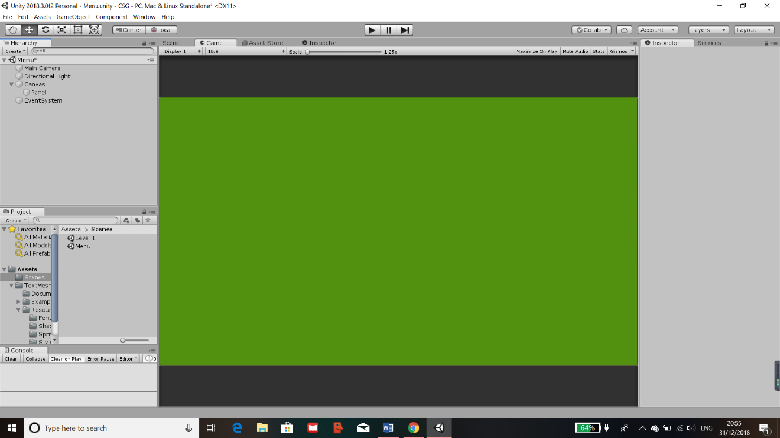To create a menu, first I had to create a new scene within my project where I can work on the Menu. The scenes that I have used and any future scenes will be placed in the scenes folder where unity can read from. This ensures separate parts of the program so that the code in the scripts wouldn’t cause any conflicts with one another. This also means that my program is separated out so that I can focus on different sections, one at a time.

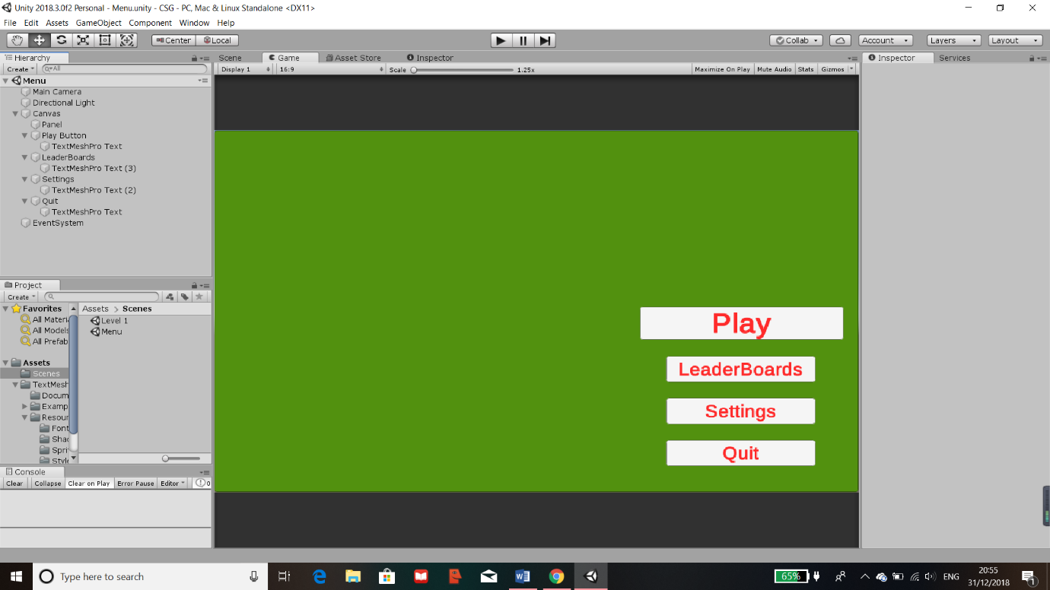The first part of the menu will need to be made on a canvas. Within the canvas contains the panel which can be edited and an image can be added later on.

Next, I created buttons for my menu and laid them out in the places they should be. I resized them accordingly so that they are the correct size then I labelled them where each button would take you.

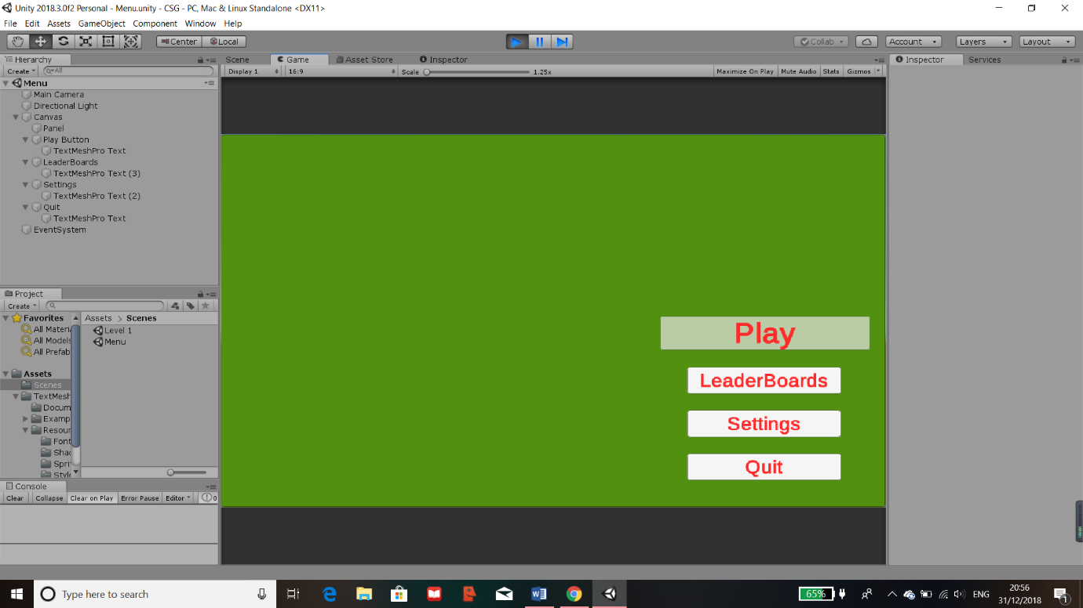

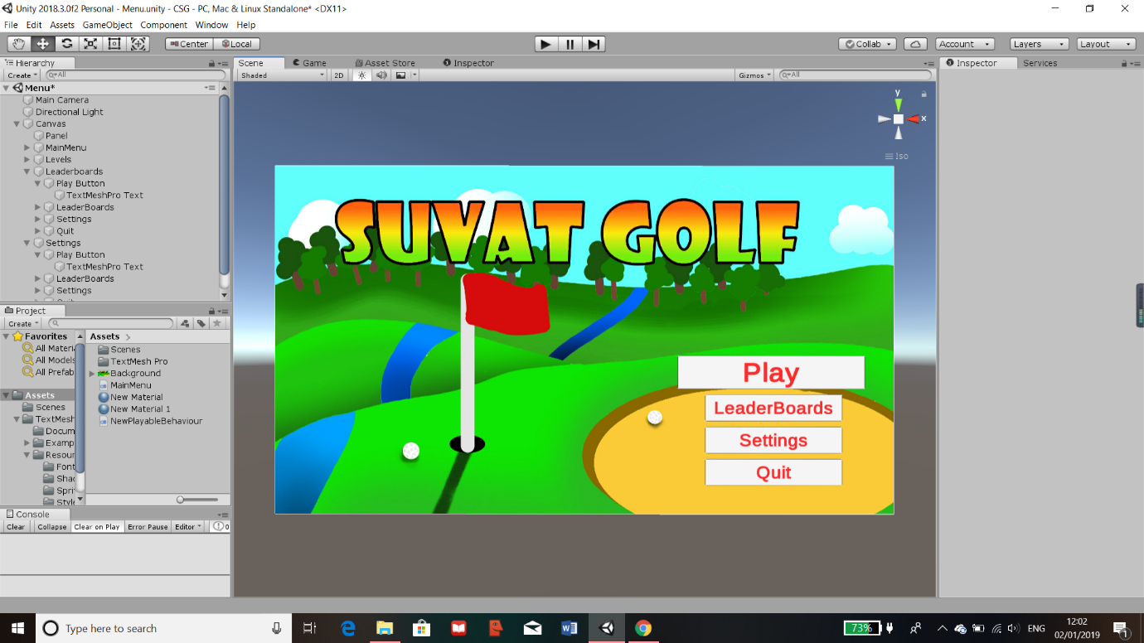The button also changes transparency when hovered over, as this is a given component for each of the buttons.

I then proceeded to update all the objects to the suitable names and import an image which will be the background for the “Menu” scene.

### Level Design

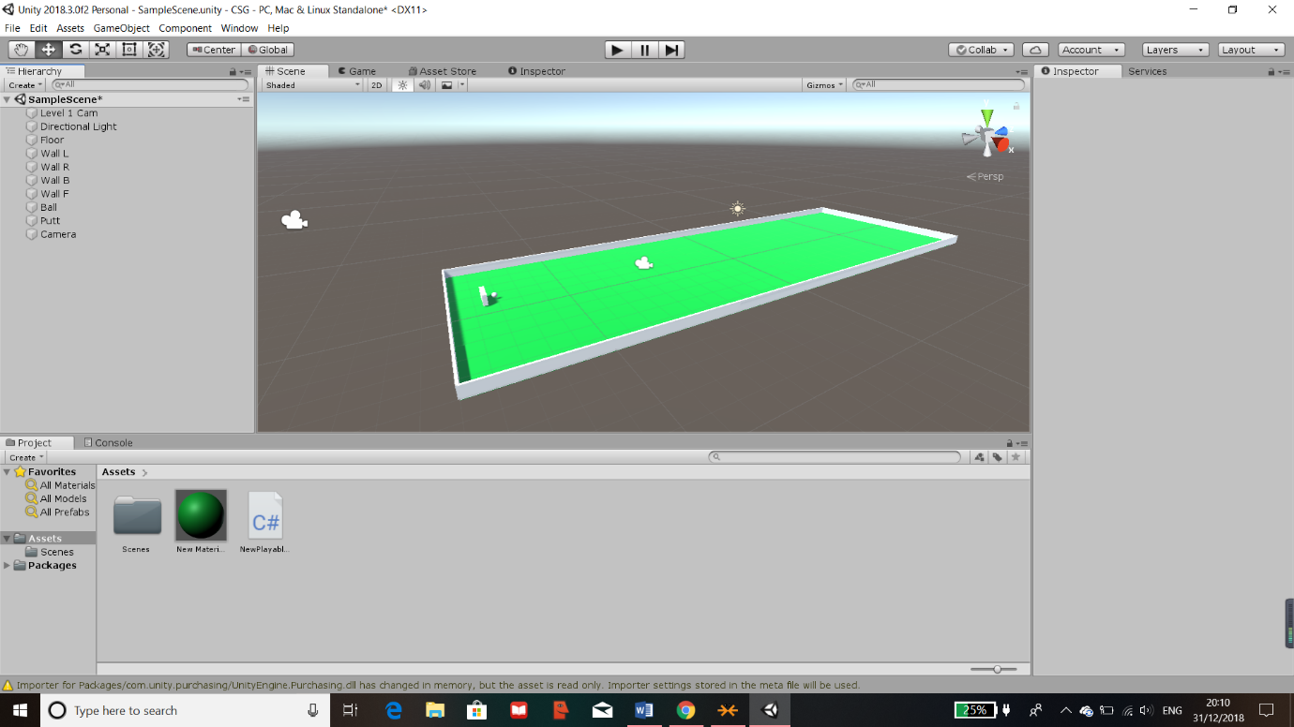The first step in beginning my coding for my project was to create various cubes and objects which would be used as the building blocks for the golf course. I had to create multiple objects each with different components, these were all amended and made on the inspector tab on the right-hand side of the image. Through the use of the built-in modules of unity, I added a “Box Collider” to all the objects that would need to have a hit box within the program.

In the above image, I have completed creating a base for the first level, I have also labelled all the objects relative to their uses which is shown on the scene tab on the left.

#### Components

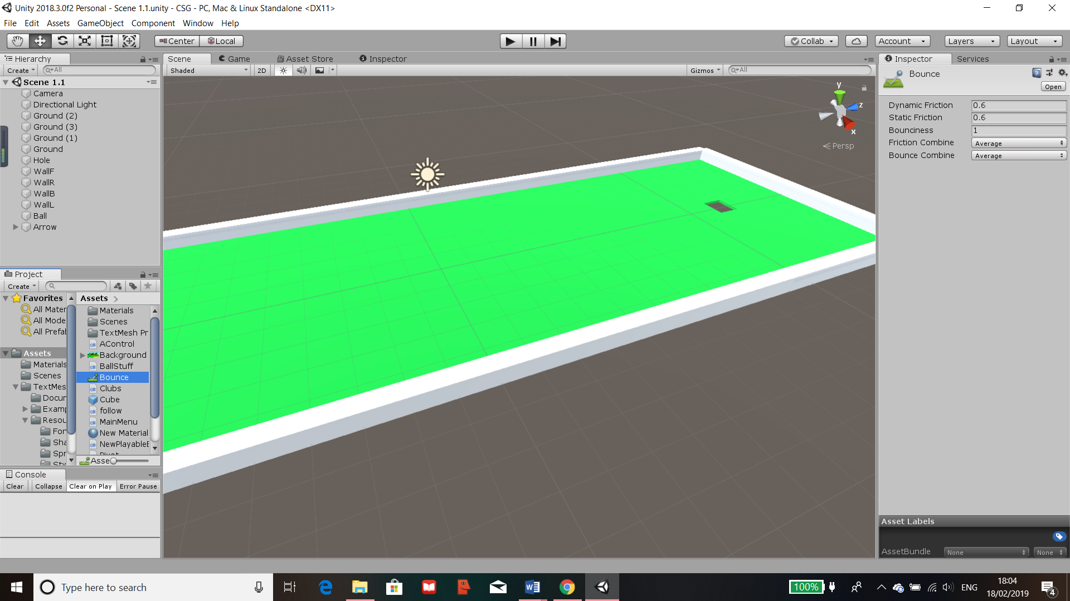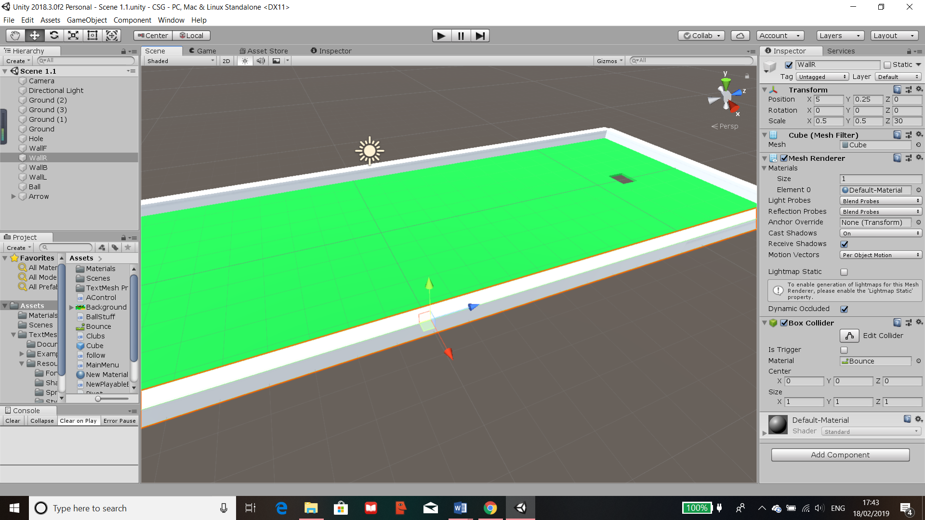

This is the “Bounce” attribute which has been assigned to all walls as the material. I have modified it by reducing the friction on other objects it comes in contact to and the Bounciness causes it to bounce back with less speed due to the friction. This would make any object it touches rebound hence I called it “Bounce”. It is stored in assets so it can be reused in other levels.

The “Box Collider” describes the hitbox of the object and there is an option to change its centre of collision. The material can also be changed. For walls such as this one, I have attached the “Bounce” attribute to the hitbox. On the other hand, floors wouldn’t need a bounce mechanic so objects like those has a default material.

The “Mesh Renderer” holds mostly visual effects on the object such as reflections, shadows and occlusions (which is how each point is affected by ambient lighting). Here you can also assign different materials for the object such as a change in colours.

The mesh is the type of object it is. Unity holds many meshes such as cubes, spheres and other custom-made ones.

The above is the name for the object/item. In the inspector tab holds all the components of the objects which can be amended. The “Transform” changes the size of the object by using the scale, the position which is changed to fit correctly within the level and the rotation which is normal.

#### Lighting

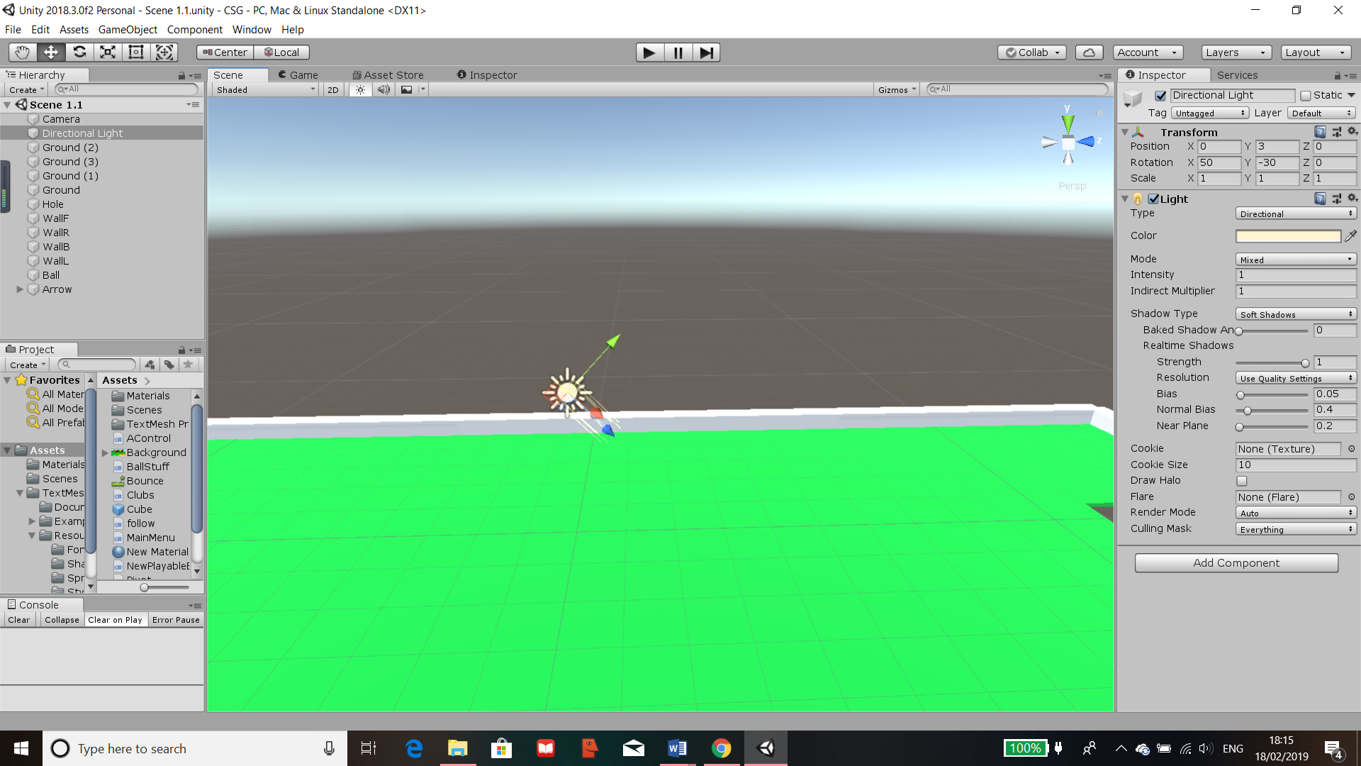

The is the “Light” as an object in the scene, this is placed in the centre of the scene and is pointed in the direction I set to provide the possibility of a shadow for the level.

The “Transform” component holds where the light object is and the rotation that it is facing.

This is the “Light” Component which hold all attributes for the light. Its set to direction so that shadows can be clearly seen. I have also added a slight hue to the light so that it is more natural.

The rest of the settings were left as the default because they either didn’t need to be changed like the strength attribute of the light or they were not needed for the level

### Camera Control

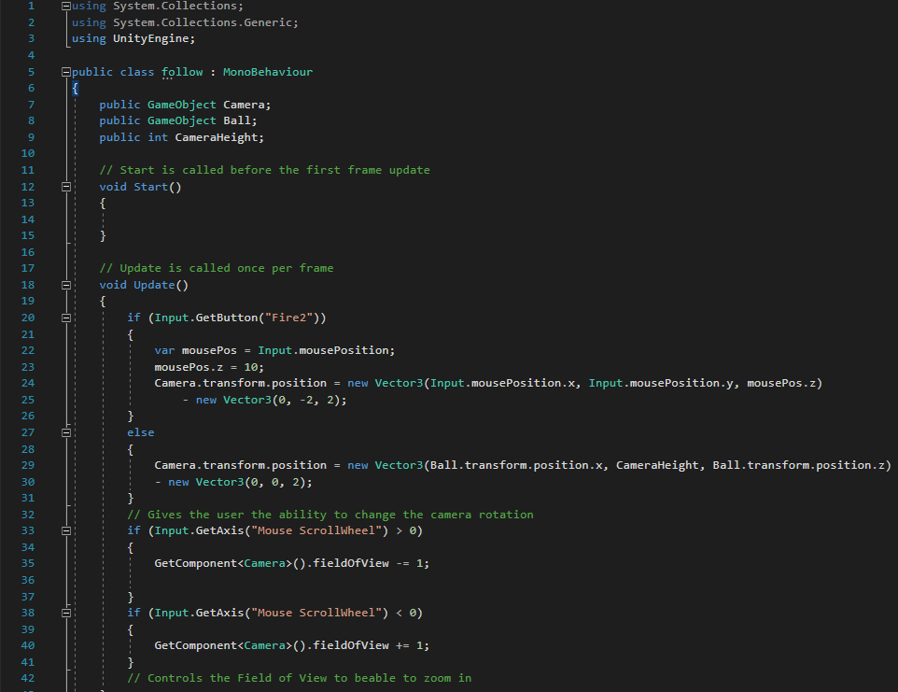

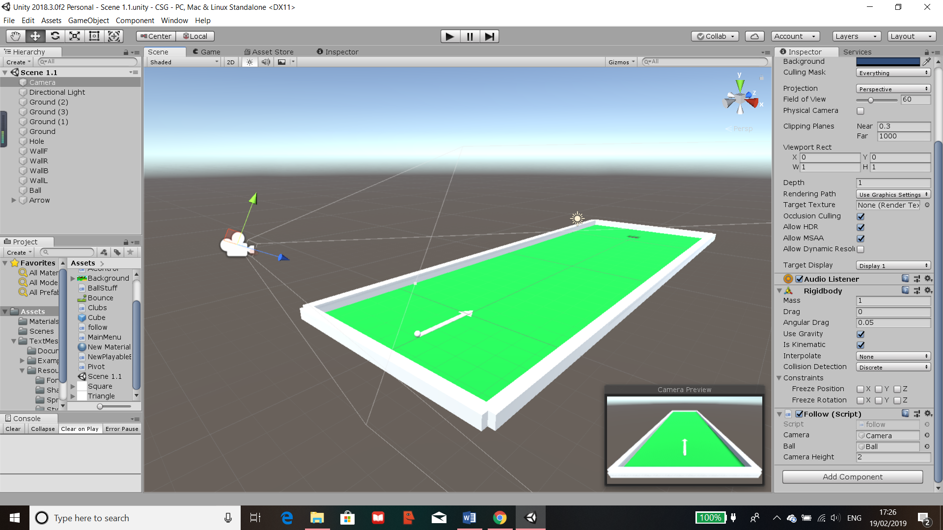Firstly, I created a script (what a class containing code is known as in Unity) for the camera as that will control what the user will be able to see. Within the script, I provided ways for the user to adjust various elements of the camera however the camera will remain in the fixed height and length away from the ball. This is done so that the play would not lose track of the ball or wander outside of the play area of the game.  
There are public variables, 2 of which are “GameObjects” and one is an integer. These are called “Camera”, “Ball” and “CameraHeight”, the values of these variable are set outside the script in the component of the camera shown below.

Through here, I have set each variable by dragging the object it is referring to into the box and the camera height by an integer. This can be adjusted if the camera needs to be higher or lower in other levels.

The elements that are controllable are the rotation and the FOV of the camera by the detection of key presses such as the scroll wheel and the right mouse button. Once the scroll wheel is detected, depending on if its increasing or decreasing, the “fieldOfView” is changed accordingly in the camera components. If the mouse click is detected the variable “mousePos” updates with the latest mouse position and it changes the camera positioning whilst the right mouse click is held down.

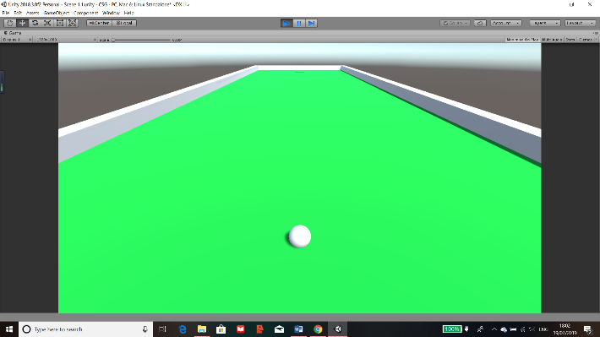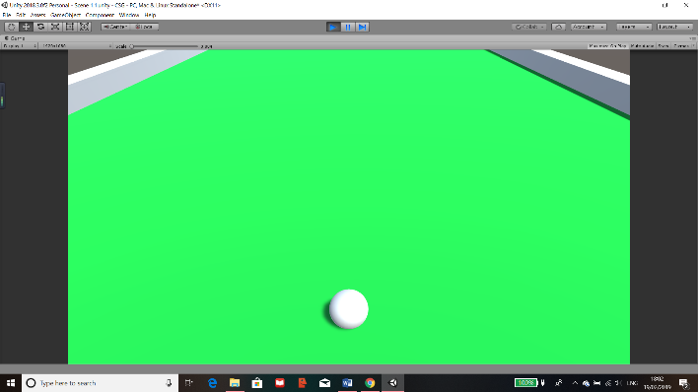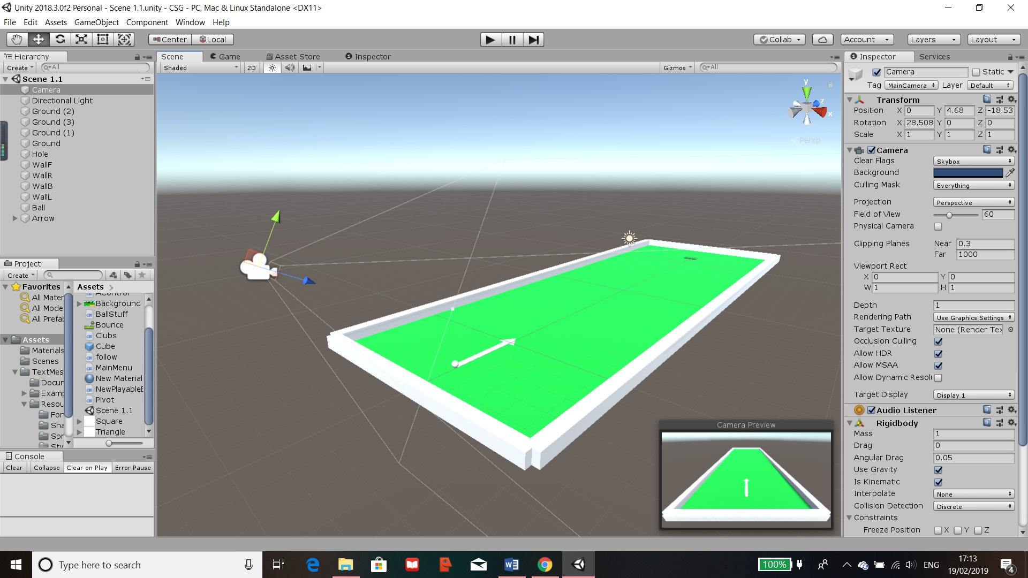The camera is positioned at the correct angle and distance away from the ball, this is checked through the “Camera Preview” shown on the bottom right. The height is then adjustable through the variable in the script. Most of the other components of the camera are left default as the game would not need any special camera settings or effects. However, the FOV level is adjusted through the script and it is defaulted to 60 every time the level loads.

FOV increased

FOV: Default, 60

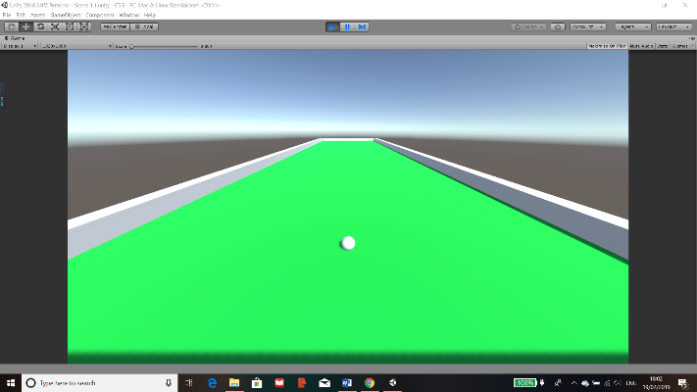

FOV decreased

### Putter/Arrow

The main designs of a putter which I will implement in this project are:

* Putter positioning (Where the putter will be relative to the ball)
* Pivot control (Which direction the putter is aiming relative to the ball)
* 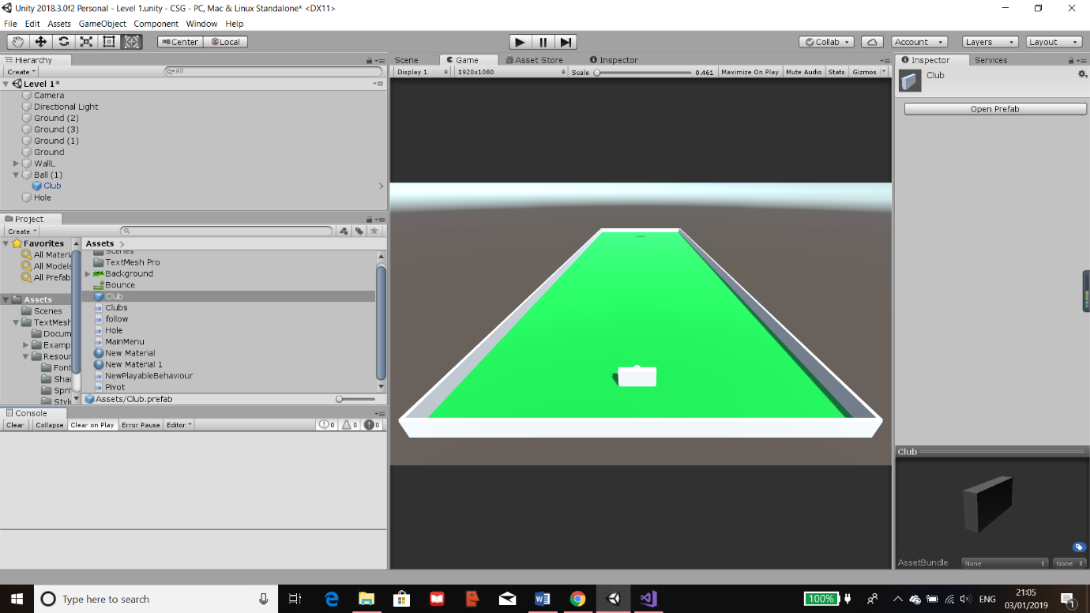Strength control (The amount of force that will be exerted onto the ball)

To make sure the putter would be in the correct positioning for the game, I have made the putter a Child Class and the “Ball” its Parent Class (Shown on the left tab). This would mean that the co-ordinates for when the putter is spawned will be relative to the ball.   
I had also created an “Object” Prefab (A saved group with at least one object which can be called upon or deleted within the script) for the putter shown in the asset tab.  
All scripts are saved in this asset tab no matter what scene they may be in. This could be changed however I have kept them all in the same file so that I can call certain features from ones that I have made previously.

Once space is pressed, Club prefab is loaded into new positions relative to the new location of the ball and all orientation and angles are reset so no errors can occur.  
The positions and angels are retrieved using “GetComponent<name>”, this gets the component of the name giving by the object that the script is attached to. I’ve done this for the “eulerAngles” and the velocity of the ball and have set it to new Vectors (0, 0, 0) to stop the ball.

If commands for amount of strength on the putter. This is done by detecting the key input assigned to each task.

Ensures the force that will be set on the ball won’t be too high to too low. Done to prevent errors.

Releases the force that was set as “zforce” which will propel the ball in the direction it’s facing.

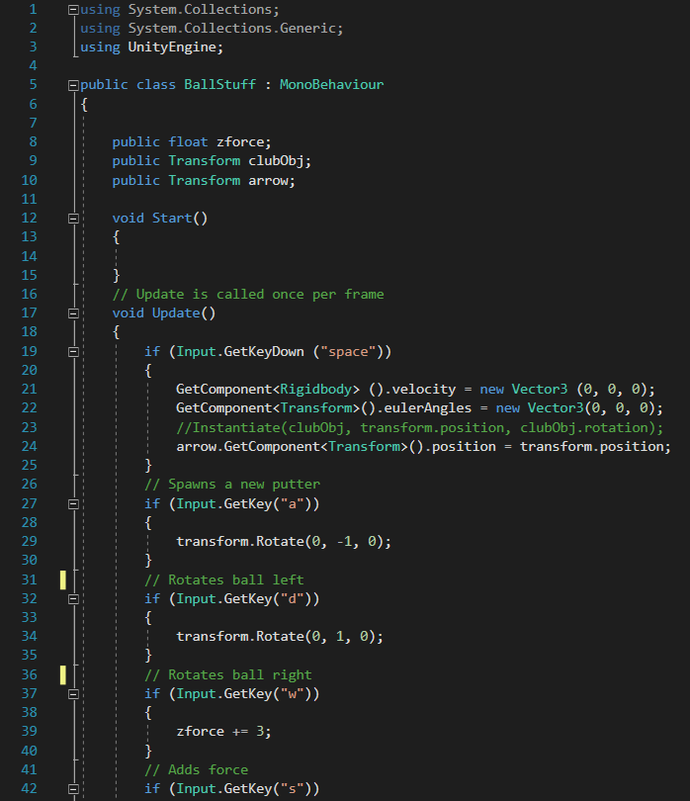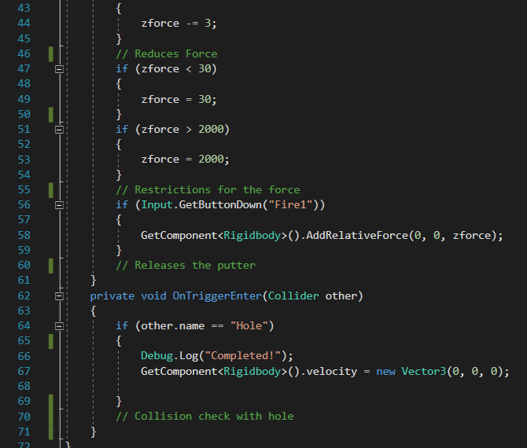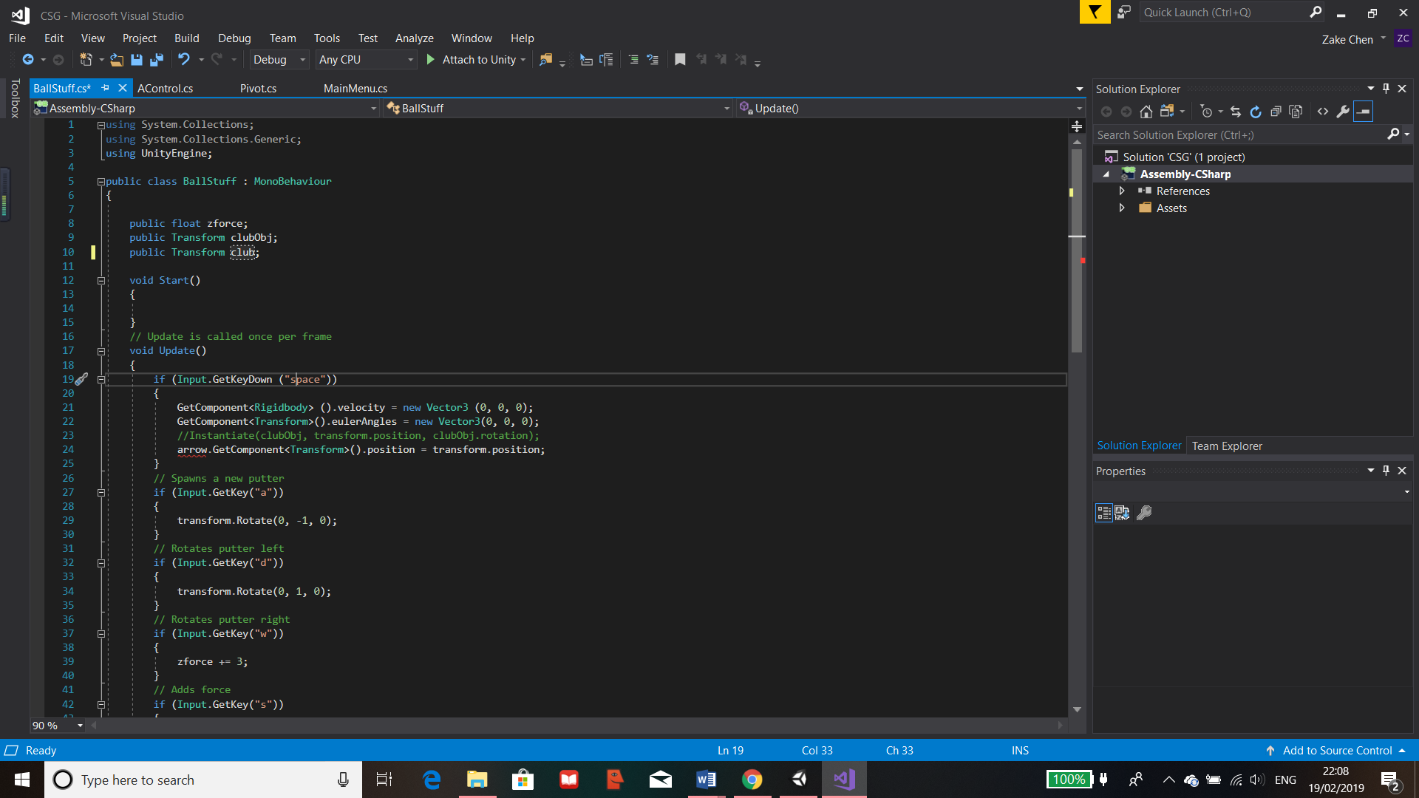

Creates a function so that when a collision occurs, it will run. In this function, if the ball collides with the object called “Hole” then it will print out “Completed”, this will later be changed to move to the next GUI. I have created an object with no physical features to be below the hole to act as a collision detector for the ball.

Public variables. “zforces” is the strength of a force stored as float. The other 2 holds 3d vectors of the positions of the held items.

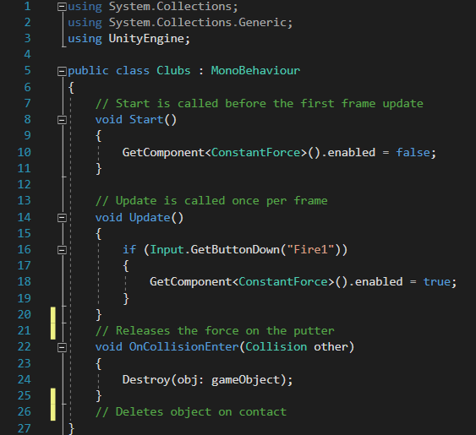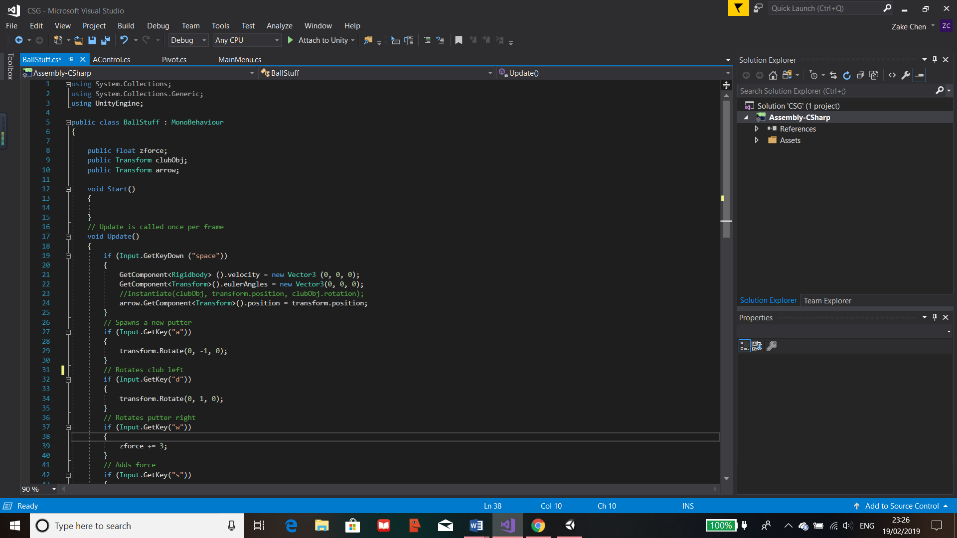

The above script uses functions to control the putter. When the scene the script is linked to, the “Start()” function will run once, this would disables the force which has been pre-set on the club by getting the component called “ConstantForce” and the bool called enabled within it. This would mean that the putter will remain motionless until this is reactivated, once this occurs, the putt will release with the current force that is stored as one of its elements in its components.

“Update()” function will then be ran every frame that the scene is loaded. This function has the code which calls a class built in to Unity for detecting a key press. I have it to detect when the left mouse button is pressed. Once it’s pressed, the component “ConstantForce”, retrieved by “GetComponent<>”, will be enabled launching the ball in the direction chosen by the user. It will also detect the keys “a” and “d” and once these are pressed, it will rotate the putter accordingly in that direction, this is so the user can aim the putter to hit the ball at different angles. This is achieved by “transform.Rotate” which looks for the transform part of the object the script is attached to then the “Rotate” part within it, the code then increases/decreases it in the y axis, which is the horizontal axis in unity for every frame the key is pressed or held down.

Finally the “OnCollisionEnter()” function is used to detect any collisions that occur on the object that this script is attached to, in this case it’s the putter. Within the brackets of the function, I have set to detect any collisions with any other objects on the scene. Once a collision is detected, the object will be deleted by the function “Destroy()” so that it can be instantiated by the script attached to the ball.

Error  
Due to the use of the putter as a physical object, on some occasions, when the object collides with the ball it would sometimes bug out and cause the ball to glitch off screen. This meant that the ball would be out of area and unplayable. Through my alpha testing, one of the testers have found that you could spawn multiple putters around the ball if the pivot was changed for each object. This would therefore create more problems.

Solution  
My solution to this problem was to replace the putter object with an arrow as this would also be beneficial to the user to be able to see clearly the direction of the ball. To fix this, I had to create a new arrow object using different shapes and creating an overall prefab for them. I then replaced everything that was related to the putter into the new arrow. Consequently, this has removed the bugs that were found in the alpha testing and I have created solution which has worked.

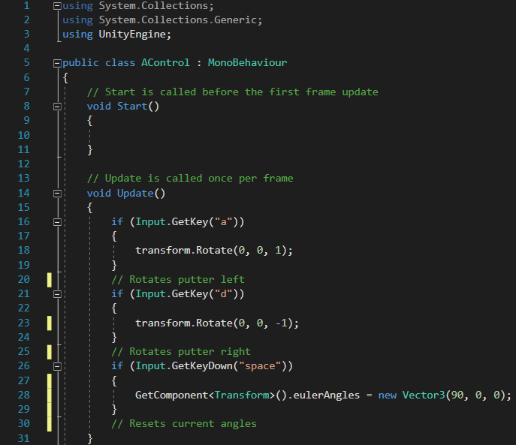

The “BallStuff” script has been amended to fix the bug, there is a new public variable arrow which replaces the club variable. There’s also an addition of rotation of the ball in the “BallStuff” script, this has to be done as there will not be a physical object colliding with the ball so that once the “zforce” is enabled on the ball, it will propel in the direction with the given amount of force.

As the golf ball is a sphere, the user will not be able to tell if the ball is rotating or not. Consequently, I have created a new script for the class called “AControl”, this would rotate the arrow the same amount as the ball so the user would know which direction the arrow would be fired at.

The script is shown above, both scripts currently contain a key detection of Spacebar, this will be later removed as it is currently use to test if resetting of the arrow and ball works. It acts as a debugging tool for me and will be replaced so that the ball and arrow will automatically reset after a given time.

#### Arrow Reset

As mentioned previously, I wanted the ball and arrow to reset automatically. To achieve this, I have amended the “BallStuff” and the “AControl” scripts to include a function which waits a certain amount of time before resetting the ball.

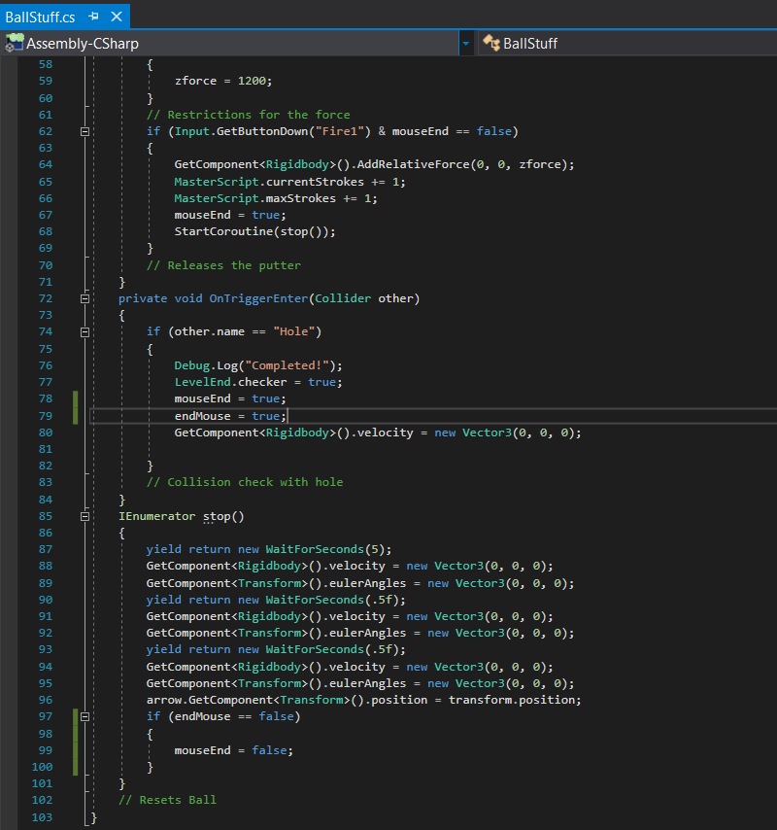I have added new bool variables called “mouseEnd” and “endMouse”. The use of these variable is to stop the spam of left click when the ball is still moving. So, when the mouse is clicked, the mouseEnd is set to true so that the function cannot be ran until the “IEnumerator” finishes, then it checks if “endMouse” is false, if so then its set back to false, if not then the ball will not reset. The variable “endMouse” is set to true in the “OnTriggerEnter”, in this function, the attached object, the ball is checked is it’s colliding with something. If it collides with an object called “Hole” then the code below this if is ran. This means when the ball collides with the hole “endMouse” is set to true meaning spam click won’t work after the level is complete. This can be shown in the image below.

I used the unity module called “IEnumerator”, shown in the class above, and made a function called “stop()”. The “IEnumerator” module provides the use of the yield command which means that I can call a yield to return a value. In this case I have used “WaitForSeconds(5)” so that the yield will call the procedure “WaitForSeconds” in unity. This means that the when “stop()” is called, it will wait the given amount of time then run the code below it line by line. I have used multiple lines of the same code as there seems to be an error because when the ball is reset, it may still move at a small fraction of the original power.

Through research I have found out that many users have had the same issues with trying to stop a moving object and I could not find a solution. In conclusion I have reset it multiple times, the first resets the ball after 5 seconds, the next two resets with a half second difference. This has fixed the problem.

After the reset code executes, the next line is to move the arrow to the ball pointing in the correct default direction. I used “GetComponent<>” but relative to the object arrow which is a variable I created at the start of the program in “BallStuff” and I have assigned the arrow Object to the variable outside of the code. This would get the component called transform which means I can get the position of the arrow and make it equal to the “transform.position” of the object that this is attached to, in this case it’s the ball.

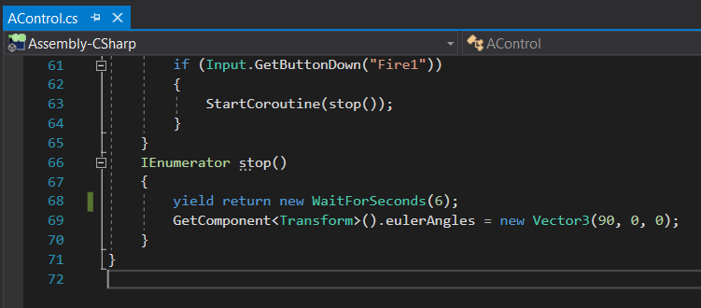

Once the ball is reset, the user will also need the arrow to be loaded as well. The position is moved relative to the ball in the previously shown script. The angle however will be reset in the “AControl” script which is achieved by a similar premise as the resetting of the ball. I used the “IEnumerator” to wait the same time as the previous script so that the command to reset the angles of the ball will execute at the same time as the ball and arrow position.

The angles are set by the “GetComponent<>” of the transform component of the object the script is attached to which is the Arrow. Then the “eulerAngles” of the arrow is retrieved and replaced with a new 3d Vector of (90, 0, 0). This is set to this value as it will face y and z at 0 which is forwards and then x is changed to 90 degrees because if it’s 0 then the arrow will face directly up instead of forwards.

#### Arrow Effects

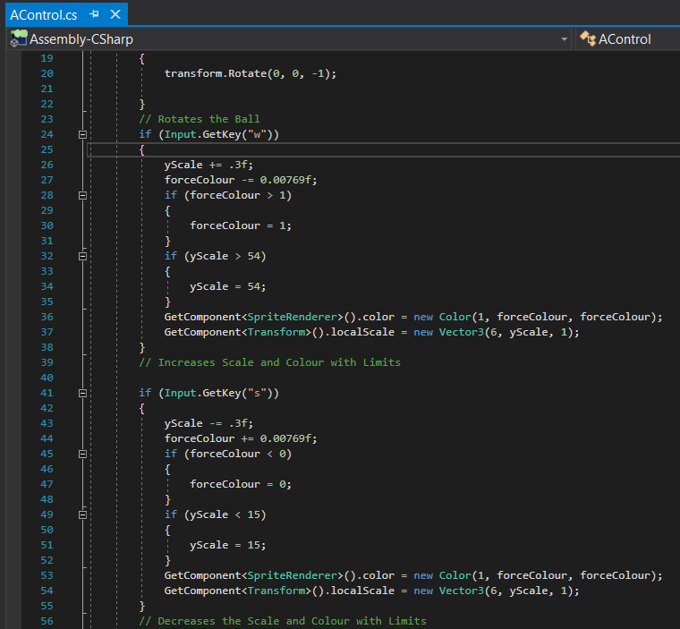The next task I worked on was the arrow effects and visuals, my goal was to make sure the visuals were informative as I didn’t want the program to display the amount of power because this means that it would be easier for the user to remember the amount of power used for the level, therefore them gaining a higher score by unfair use.

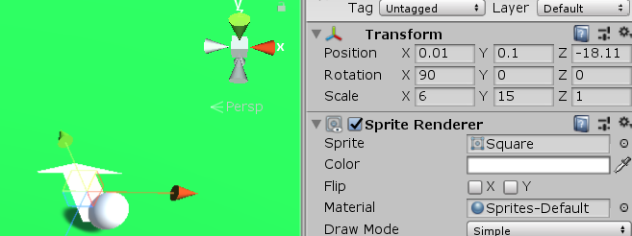To get the arrow to change length and colour, I would have to add additional code to the script “AControl” on the key detection “w” and “s”. I set a new float variable called “yScale” and for each frame the key is pressed it either increases or decreased “yScale” by 0.3. I then tried different lengths to see where the arrow should be limited to. This was done through the Unity’s main UI by changing the Scale of y in “Transform” shown below.

I found that the arrow should has 15 as its smallest length and 54 as its largest. In “BallStuff”, I have the force limiter of “zForce” as 30 and 1200. This has been changed from the previous value along with the change of “zForce” increase and decrease of 9 instead of 3. This was done because 2000 was too large of force and 3 was too small of a force change.

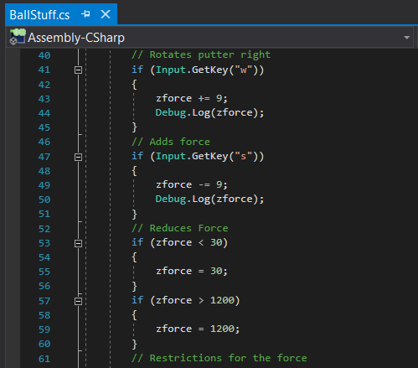

As there is a difference of 1970 between the 2 force limiters, I then used this to find a suitable number for the “yScale” to change by so that these would be in proportion to one another. I also had to do this for the colour change of the arrow. This is how I got the “yScale” value of 0.3 and the “forceColour” to 0.00769. Both of these attributes are changed throught “GetComponent” but once searched for the “SpriteRenderer().color” and the other as “Transform().localScale”.



This would then change the arrow relative to the variables “forceColour” and “yScale” whenever “w” or “s” was pressed or held down. The colour was changed creating a new colour using RGB as I wanted this to change from white to red so “forceColour” would begin at 1 then decrease to 0 to become red as red is “Colour(1,0,0)”.

“yScale” was changed by setting the “localScale” to a new 3d vector which included the new “yScale”. As “yScale” increases, the arrow length increases, as it decreases, the length decreases.

However, the script “AControl” only refers to the arrow neck and not the head as that is where the object was attached to. This means that I had to create a new Script which I named “ArrowHeadColour” which does the same thing as the “AControl” but only the colour change as the arrow head didn’t need to be scaled.

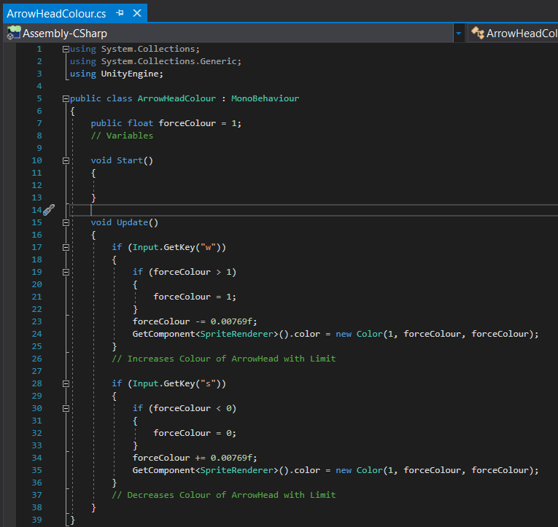

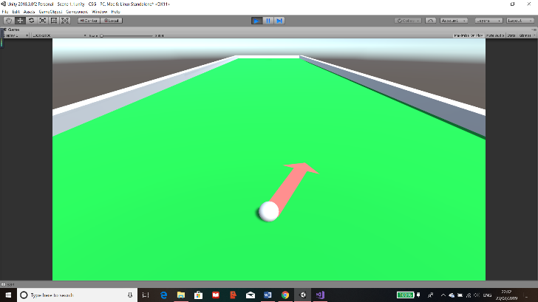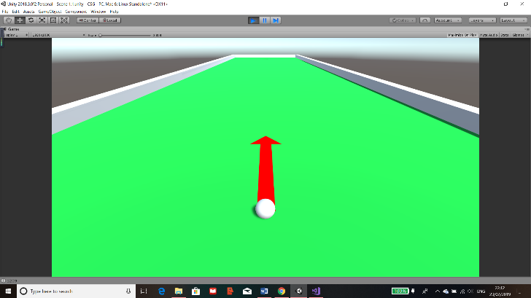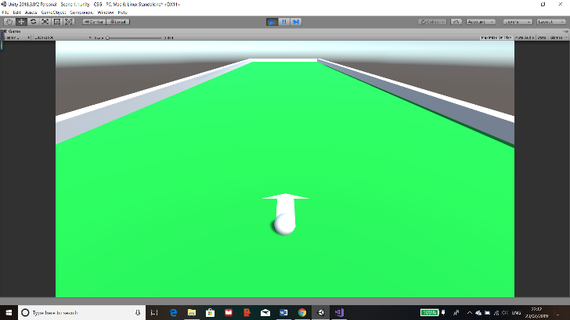

Here it is when the force is in between, the colour gradient works as an increase in force is an increase in the colour. Also, this works when the arrow is angled

Here is the arrow fully extended meaning a max force of 1200 and a max scale of 54. Also, the colour is fully red.

The arrow at the default state when the scene is loaded. The scale at 15 and the colour as complete white

### Stroke Counter

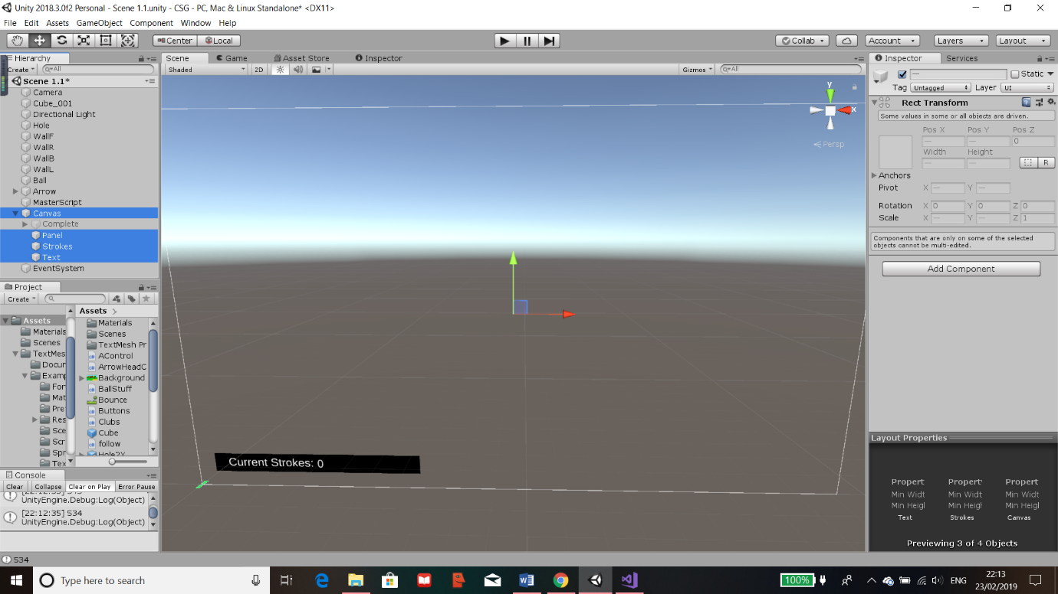The next phase of my project was to establish that the user knows how many strokes they have had in each level. This ensures that their goal is to get into the hole but using as few strokes as possible.

I first created a canvas in the scene “Level1”, the canvas is an UI Object and it means that the canvas will display as an overlay for the user. This means even if the golf course seems small at the bottom left, it will remain the same size and the canvas will scale accordingly. The canvas can be changed and modified in a lot of ways and lots of objects can be added to it, the ones that I will mostly use are images, panels, “TextMeshPro”, text, “scrollPanel”, buttons and possibly others. The use of the canvas it to provide a GUI for the user. Everything that will be added to the canvas should be created as a child of the Canvas. This would make the Canvas the parent of all the UI’s meaning that if I want the UI to deactivate all I would need to do is to change the parent.

The current canvas I have created has a black panel and 2 texts, one of which is the “Current Strokes” and the other is the number. The reason this is separate is so that when I create the script, it can change the number in the text object. Consequently “Current Strokes” will not change. The highlighted objects are the ones used for the strokes display.

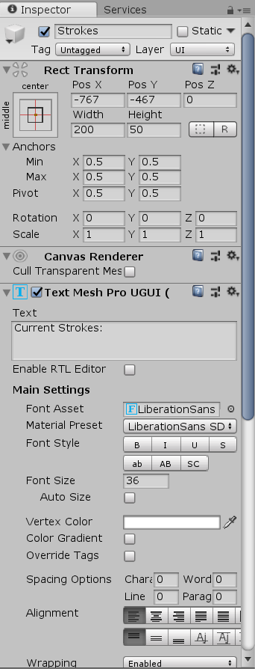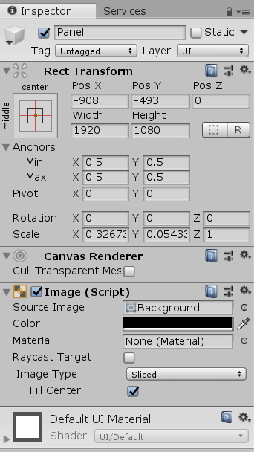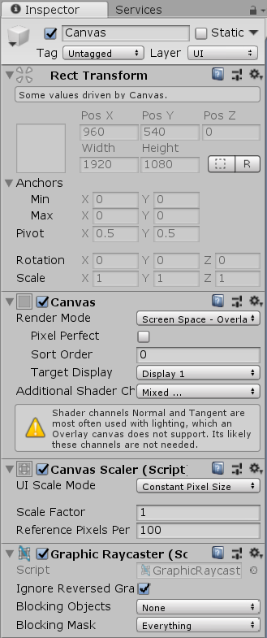

These are the main components of each object I have made. The canvas is shown on the left and most of the attributes were correct because this creates a GUI on “Display 1” with a normal “Scale Factor” from the components “Canvas” and “Canvas Scaler”. The other components did not need to be changed for my project.

The middle is a “TextMeshPro” text object which is an additional package provided with unity. This is basically an improvement on the usually text objects that unity usually provides. Through this I have changed the components “Rect Transform” and “Text Mesh Pro UGUI” to positon the text correctly and what is displays.

Finally, the last object I have used is a panel which is a background for the texts I have used. I have scaled the panel relative to the size of the text that I want and I have changed the “Image” component of colour to black so that the text is easily readable.

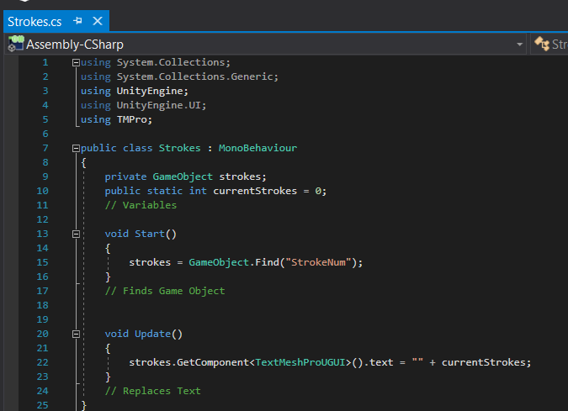This is the main script for the Stroke Count, I have called it “Strokes”. To achieve a counter, I didn’t need too much code so this script was relatively small.

It contains 2 variables, one which is a private GameObject called “strokes”. This variable is private meaning that it is only referenced to in this class and cannot be changed. The “strokes stores the gameObject called “StrokeNum” which holds the text for the number of strokes. To make sure the variable is referencing the text, in the “Start()”, I set the variable to the GameObject by using the Unity function “Find()” which looks for an object with the exact name. The other variable is an public static int, it’s an integer variable called “currentStrokes” and static means that it can be referenced and changed from in other scripts.

In the “Update()” function, it looks for the component “TextMeshProUGUI” of the variable “strokes” and sets the text to be replaced with the “currentStrokes”. This is done in the “Update()” so that is will always stay up to date.

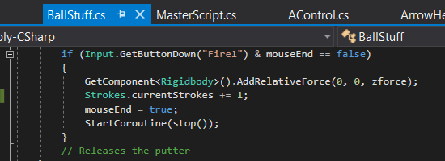

In the “BallStuff” script, I have added a line of code which calls the class Strokes and adds one to the static variable “currentStrokes”. This means that every time the user clicks and the ball moves, it will add 1 to the counter. Additionally, due to the fact that I have made sure that left click can’t be spammed, this means that the counter can’t be spammed either and only adds 1 if the ball moves.

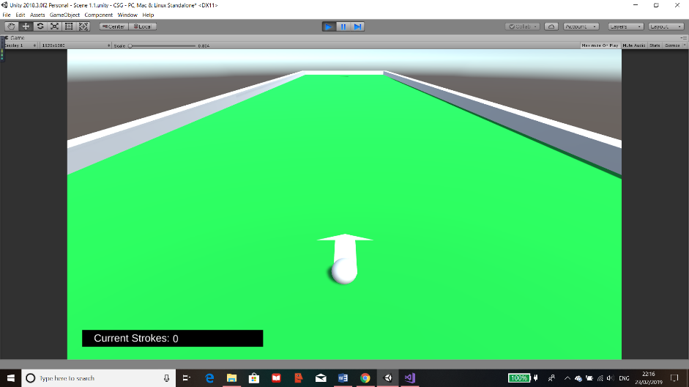

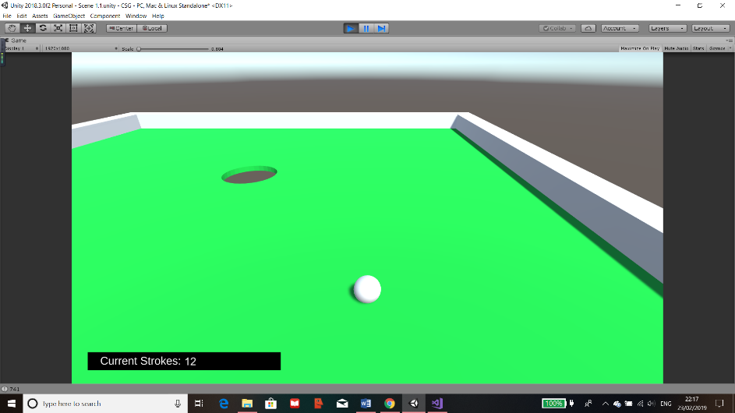

As the images show, the display is presented correctly and doesn’t obstruct anything important. Also, it increases correctly as I have hit the ball 12 times but have clicked the mouse a lot more whilst the ball is moving. This means that the code works and it doesn’t take into account the possibility of spamming left clicks.

### Level Completion

After the user completes the level, I plan to create a quiz which pops up but does not cover the screen so that they can still see the level and the strokes counter.

#### Difficulty

Before the actual quiz, I want to also create a difficulty so that they can get questions depending on how confident they are in SUVAT. I have created a new panel and named it Difficulty. Then I proceeded to implement 3 buttons each named after what they would do. The main button components can be seen on the right in the inspector. The component “Button” is what makes it act as a button. It has attributes such as the colour when it’s on screen, the colour when a mouse is over it and when it’s clicked, also it has an “On Click” which can be used to called function I have inputted into it or to set objects or variables as true or false.

The panel was created as a child of the empty gameObject “Complete” which is a child of the parent “Canvas”. The buttons are then children of the Difficulty panel and in each button, they have a text object as their child object. Each text displays each corresponding button.

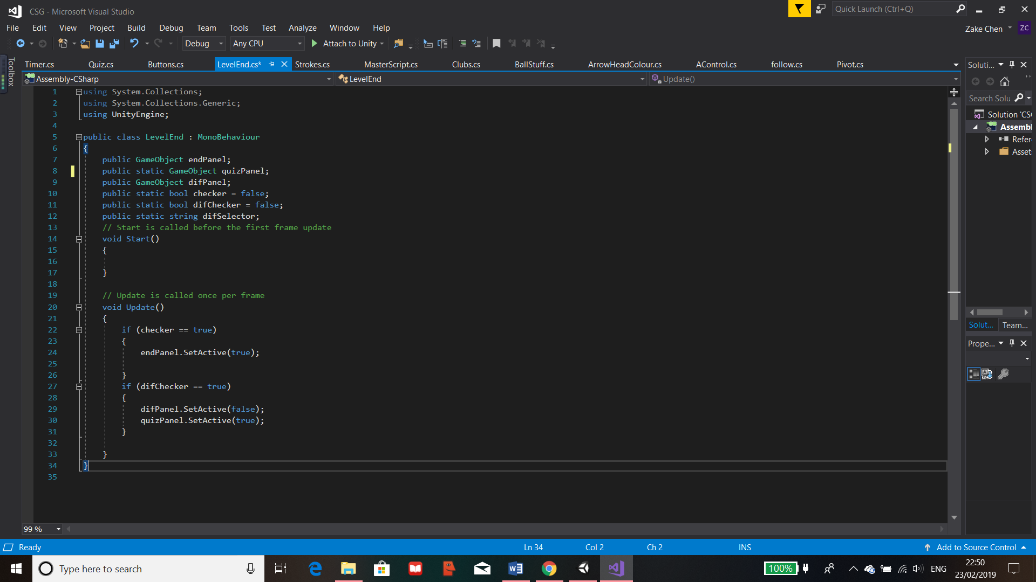

In the “LevelEnd” script, there are 6 variables, 3 are GameObjects, 2 are bool variables and the last one is a string. The GameObjects are used to set the assigned objects to these variables so that I can use them to either set them as active or inactive by the function “SetActive()”.

In the update function, the bool “checker” and “difChecker”, are used to see if they are true. If this is the case, depending on which one was true, the relative panels are set as active or inactive. If its “checker” that’s true then the “endPanel” is shown, this contains the difficulty as it’s a child of the “endPanel”. If “difChecker” is true then, the difficulty panels become inactive and the quiz panel is set as active so that the quiz can be shown to the user.

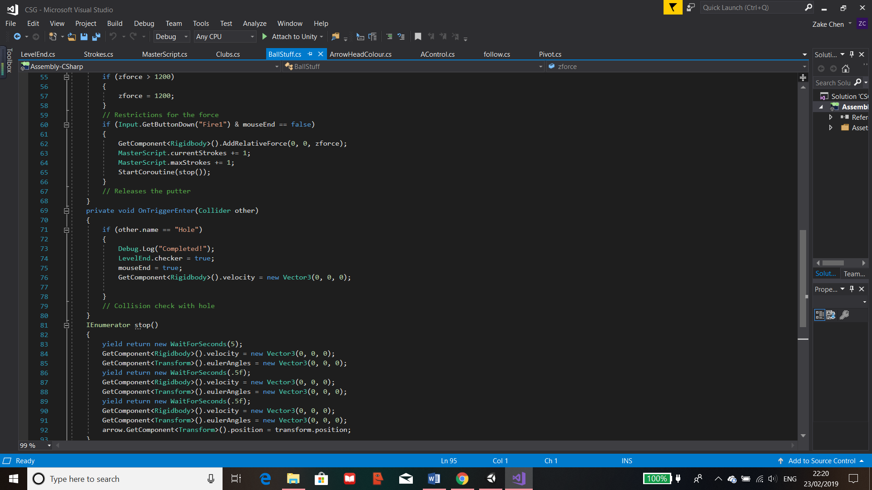

To get the difficulty panel to appear only after the level ends, I have added a line of command which call the class “LevelEnd” then changes the variable checker to true so that the panel can be displayed. This will only be set to true when the ball collides with the hole which is when the level is set to end.

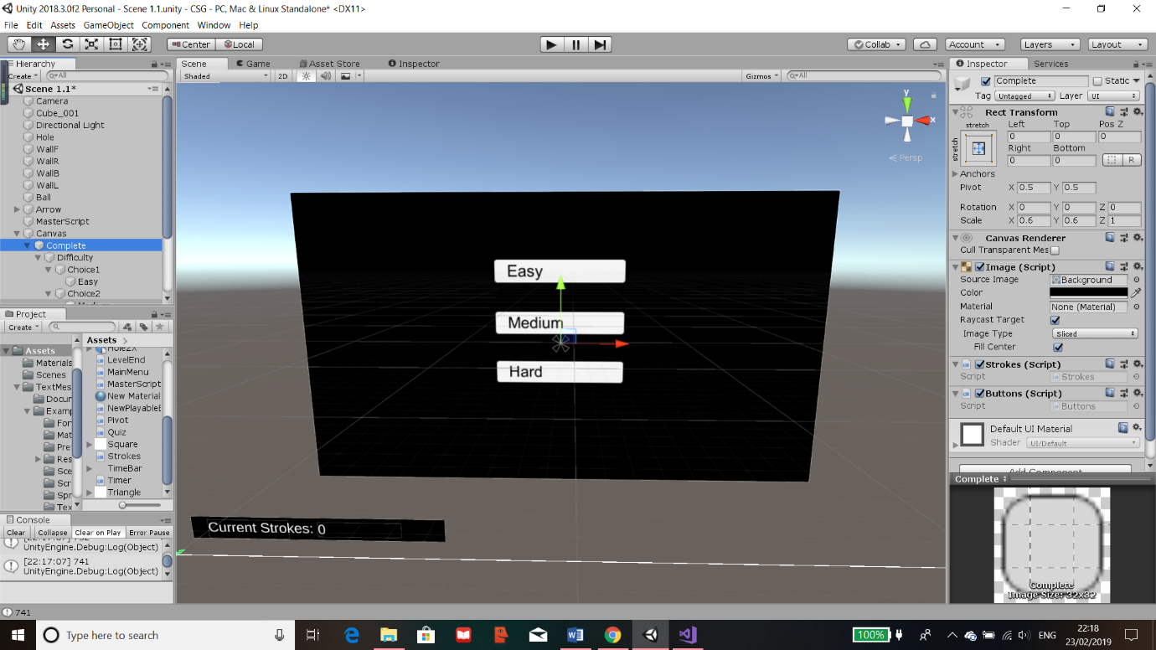Whilst I made the difficulty panel, I have also prepared the quiz panel along with the buttons I was going to use. This was because they are going to refer to the same scripts. I have created the scripts and have attached it to the “Complete” panel shown in the components on the right. The scripts are “Strokes” and “Buttons”.

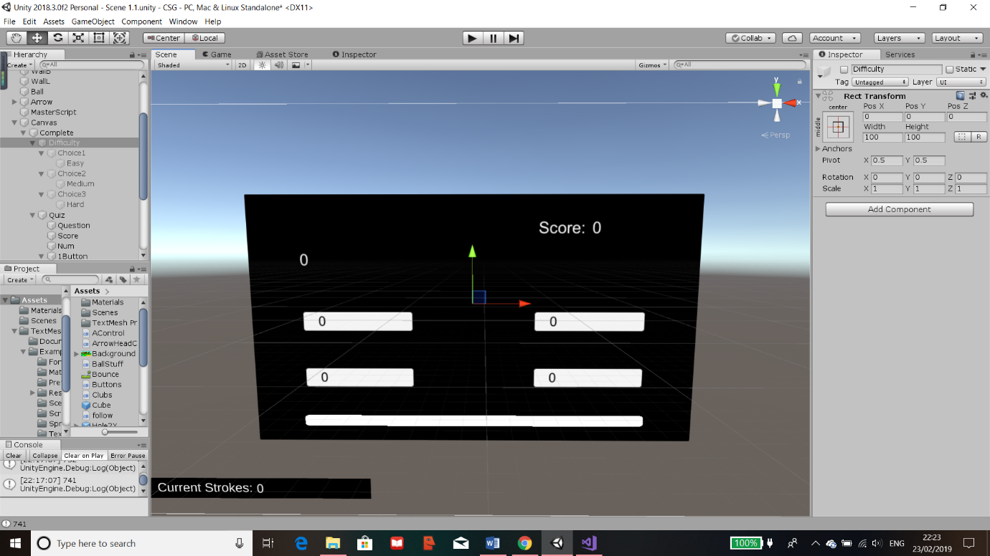

This is the panel for the Quiz, it contains a text object for the question, the score displays on the top right which are made up of 2 text objects. Then 4 buttons with texts for the user to answer the question. Finally, I have prepared an image on the bottom for the timer which will be implemented in the future.

#### Buttons

Each of these functions correspond to each button for the quiz, they are numbered to the choice that the user’s answers. They’re functions so I can ensure that the button would call the correct function within the script to be executed. The variables are then used in other scripts to execute further code.

I have initialised the variables shown. These are all Boolean and static as they are referenced out of the script. There are only Booleans so that they can be used for if the button is pressed which will change the bool.

All the variables are set to false in the “Start()” instead of being defined when creating the variables. This is done so if the user resets or replays the level then they will be set back to this.

These functions are for the difficulty panel shown before. They will be attached to the correct buttons. “LevelEnd.difSelector” finds the static variable “difSelector” from the class “LevelEnd” and changes the string to the difficulty the user will select. The variable “difChecker” is called changed to true so the program knows that a choice has been made and will execute code to move to the next panel I assign.

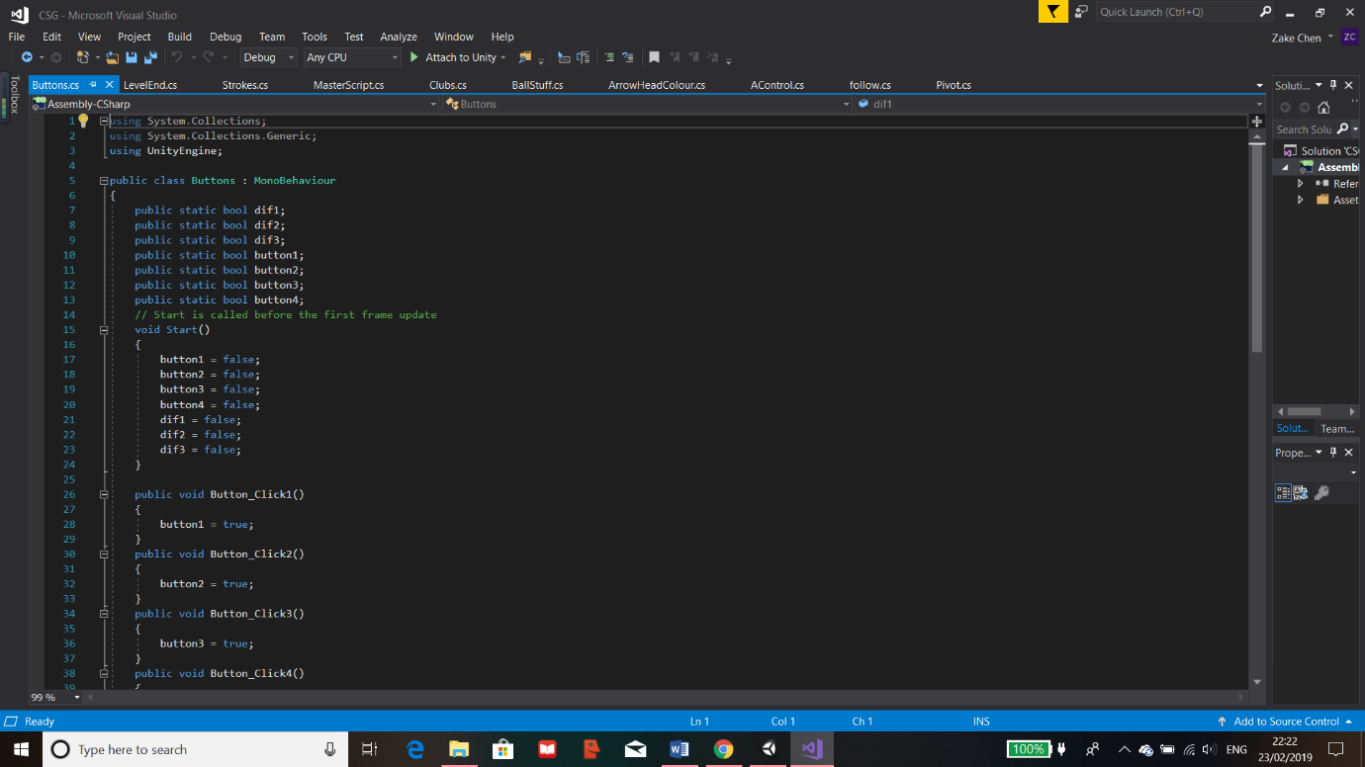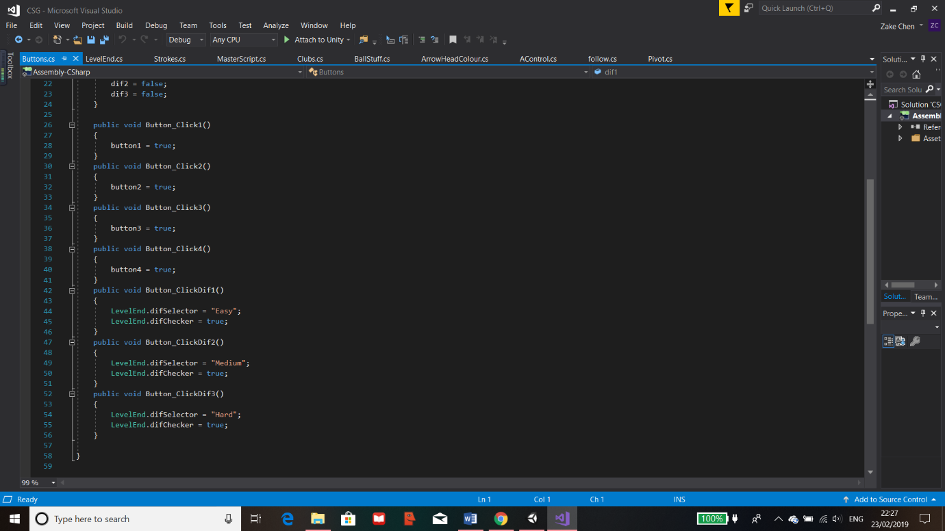

This script is for the use of all the buttons that are in this level. Each function is for a specific button and its action that it will provide for the program.

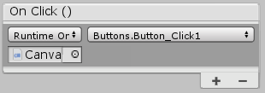To have this work for their specified function, each button will have their “On Click()” component be assigned to the object containing the script. Then Unity will recognise the script which means that the function can be called by the button when pressed.

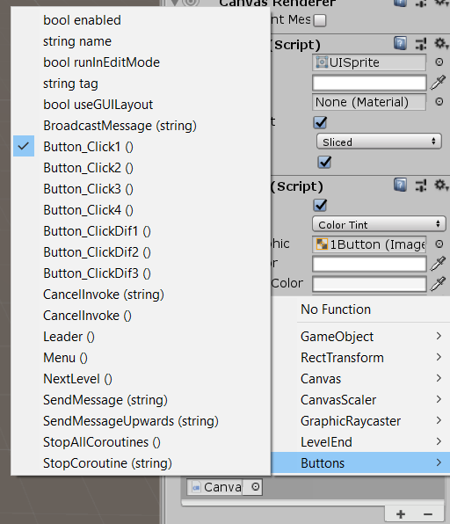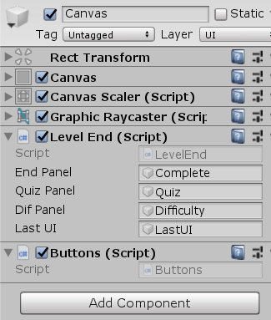In this case, it references the Canvas which contains the script and the function can be found and selected in the drop-down menu on the right.

As the image on the right shows, there are lots of options included provided by Unity but it also displays the function within the script of the object attached. This is how the button calls the function when activated. I have assigned each function to the correct button ready for the Level.

### Quiz

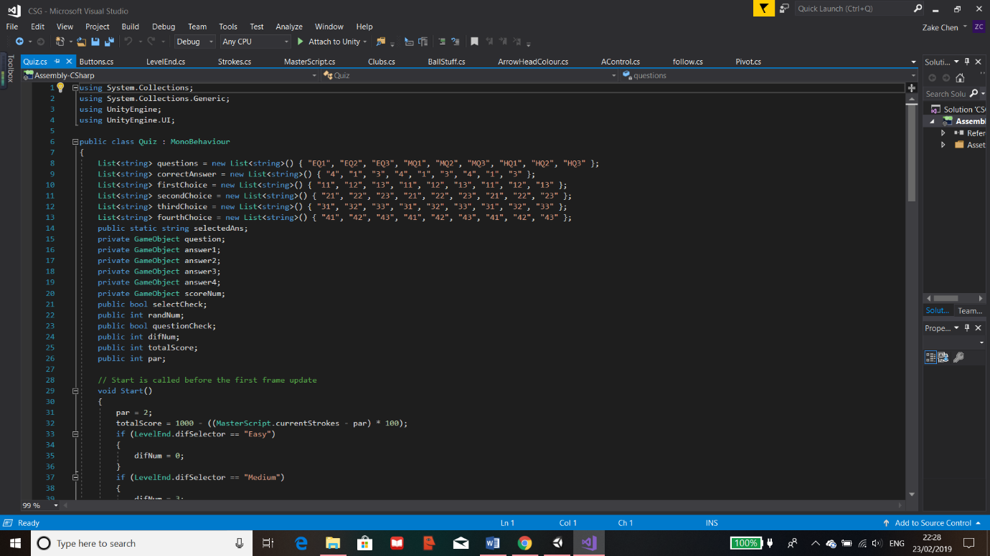Since the buttons are all working and set, I programmed in the quiz which will display a random question based on the difficulty previously chosen with the questions corresponding answers.

First of all, all the variables are defined at the start of the program and their types are also displayed. For the quiz, I have also used lists to store the questions and answer. Currently the questions hold placeholders but this will be changed in the future. The “questions” List holds all the questions where “EQ1” stands for easy question 1 and “MQ1” stands for medium question 1 and so on, these are currently used to distinguish between the difference in the questions. Then there is the 4 choices list each hold an answer to display for each of their buttons. Finally the list ”correctAnswer” which holds the correct answer as a number, the number is referencing the correct list.

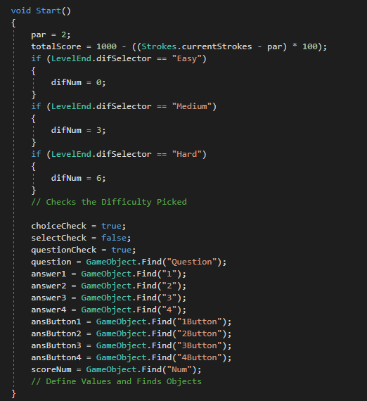

The next part of the code is mostly for defining variables. The “par” is for the current level and the current “totalScore” takes into account the number of strokes the user has gone over, if any. The “difNum” varies depending on the difficult selected which is retrieved from the static variable “difSelector” in the “LevelEnd” class.

The rest is to define some Boolean variables and to get the code to find the GameObject for each of the variables instead of assigning them in the Unity menu as this would be easier.

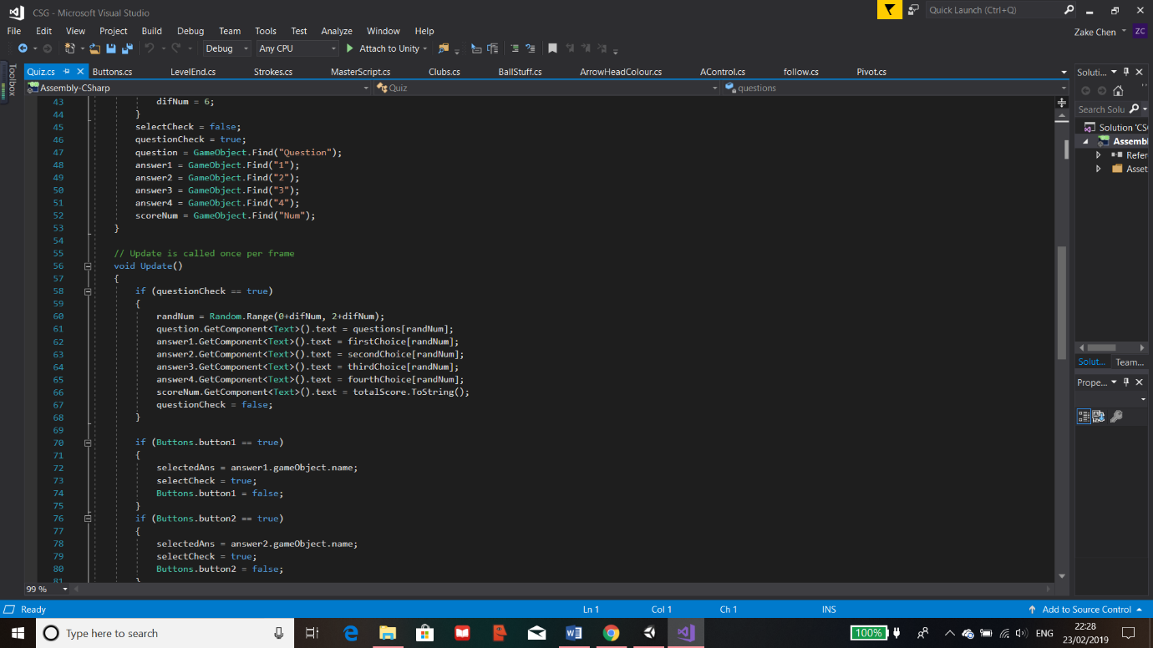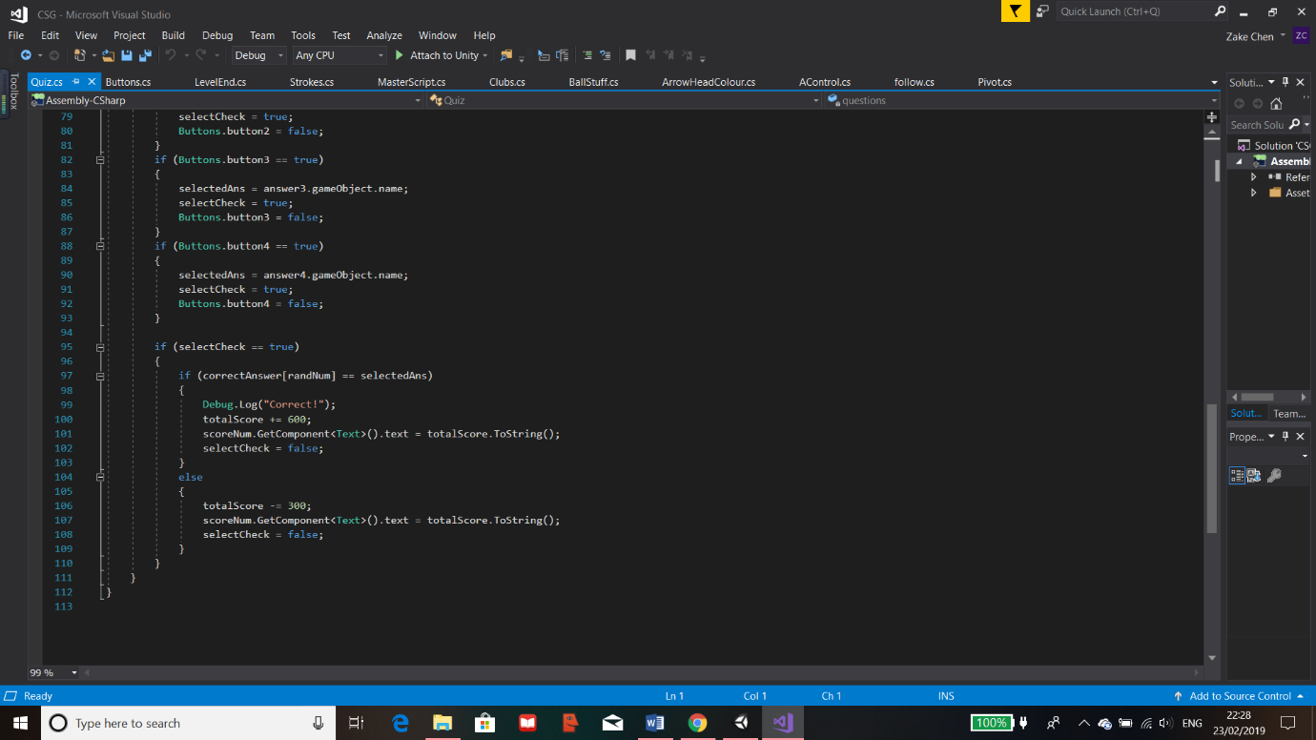

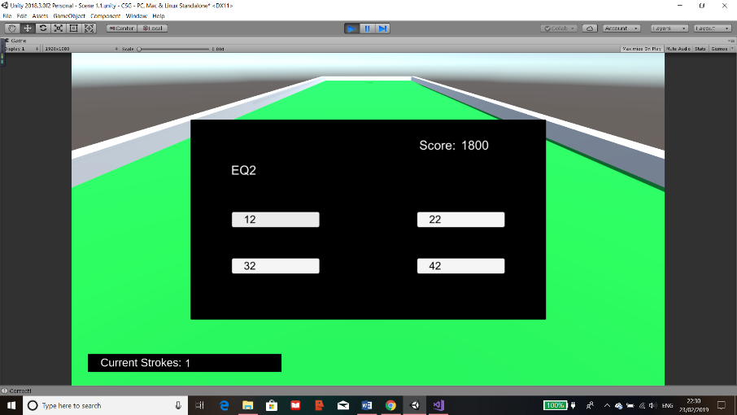The code shown here detects which button has been pressed from the reference of the class “Buttons”, once this is true, “selectedAns” becomes the answer the user selected and “selectCheck” becomes true. Once its true, it runs additional code which displays “Correct” if it was right in the console this is for my debugging, then depending if its right or not, points are changed accordingly and the score is changed. Then the Boolean is reset.

The code has worked as it shows a random question and I have clicked all the incorrect answers first and nothing happened which is what I wanted. Only when the correct answer is clicked, the console displays “Correct” which is on the bottom left of the window.

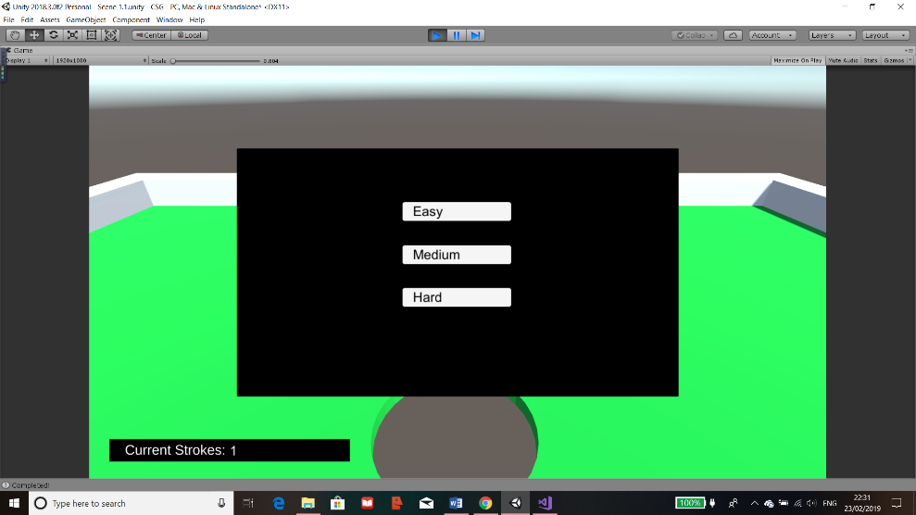

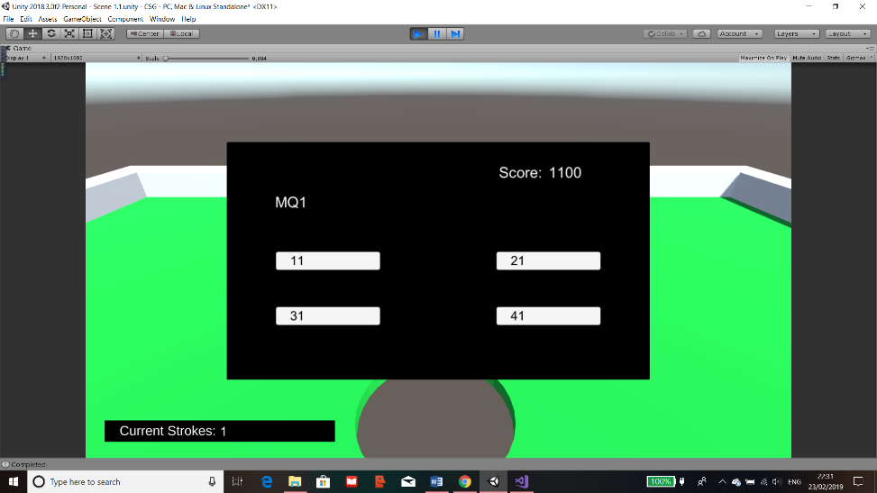

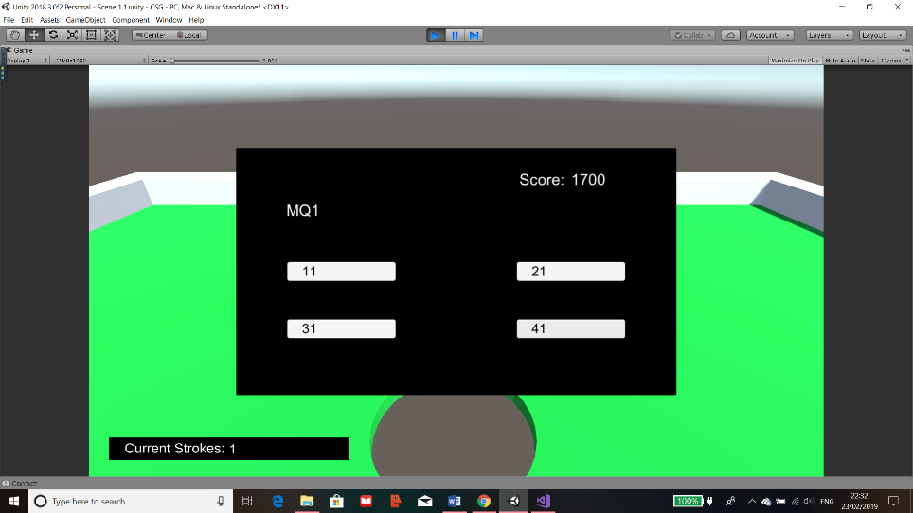

This was a test to see if all the panel switching and scoring works. As the images show, after the level is completed, the difficulty menu shows and when I chose medium, a random medium question appeared and the score is 1100. After I have answered the question correctly, the score increases to 1700.

#### Timer

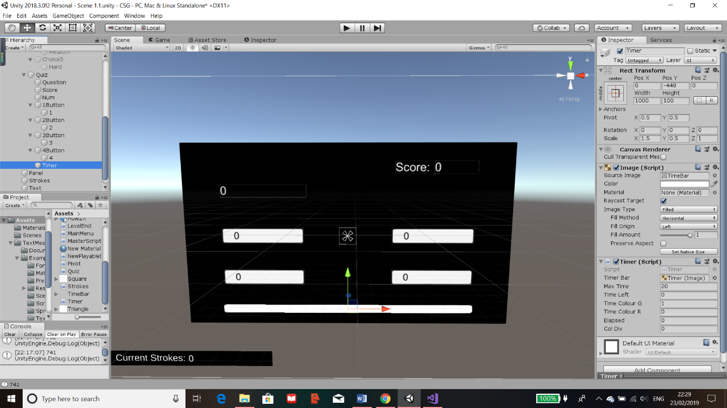The timer will be used to give the user a suitable amount of time to answer a question. If they fail to answer a question then points will be deducted as if it were answered incorrectly. However, if it was answered correctly, the score will now increases depending on how long the user took. Once the quiz section is completed, I plan to add another panel as the next UI to display their final score.

To create a timer, I added a plain image and set a fill to horizontal in the “Image (Script)” component. This means that when I reference this in the script, I can set the amount the image fills by, full as 100% and empty as 0%.

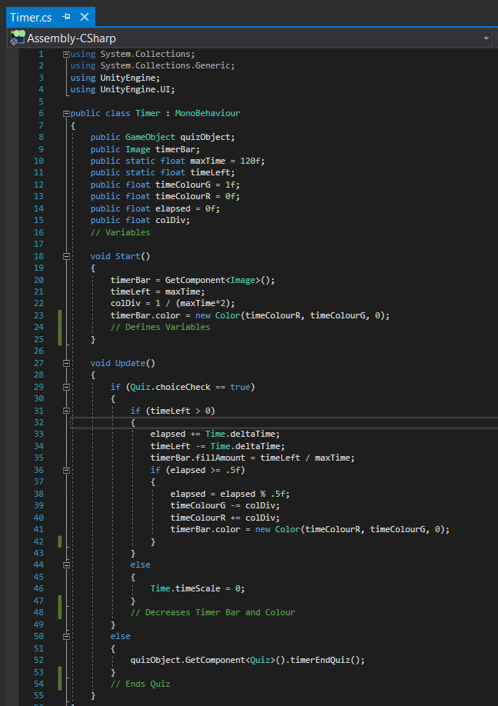

Creates the variables to be used

“timerBar” is defined to be referring to the component called “Image” under this object. “timerLeft is tused to countdown, “colDiv” establishes the amount of gradient change depending on the amount of time and the colour of “timeBar is set to green to start with.



Once a choice is detected, from static variable in “Quiz” class then time begins to count down by using “Time.deltaTime”. This is part of a Unity module where a number is incremented for each second. I used this to count down for the “timeLeft” and to count up for the “elapsed” time, this is achieved by either the “+=” or the “-=” sign which means add or subtract from this variable. Then the “fillAmount” is decreased relative to time left.

The final code is to call a function in “Quiz” which ends it when the timer is 0 or a choice is made which is in “Quiz” shown before.

From my beta testing, they wanted to see a gradient change in colour. To achieve this, this IF statement executes every half second the “elapsed” variable is larger than 0.5. For each timer it is, the “elapsed” timer is modded by 0.5 which will reset it to 0. Then the “timeColourG” and R (Green and Red) changes where red increases whilst green decreases. This sets the “timerBar.color” to the new colour. These repeats until “timeLeft” is 0 or less, which will set the Scale to 0 meaning the bar will be empty.

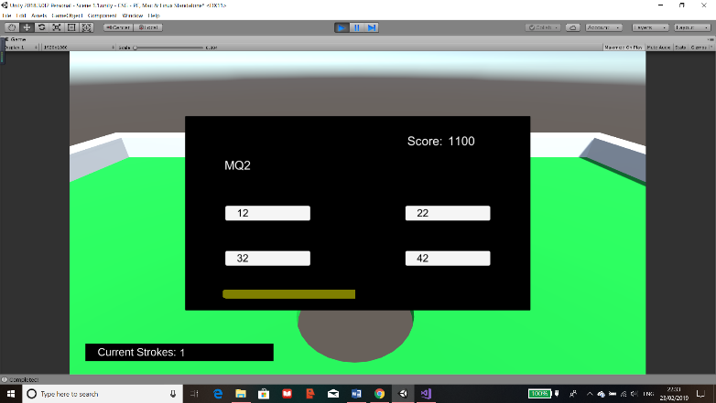

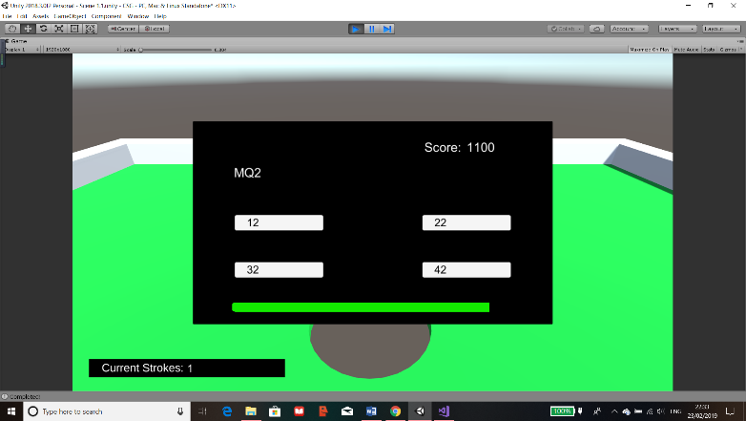

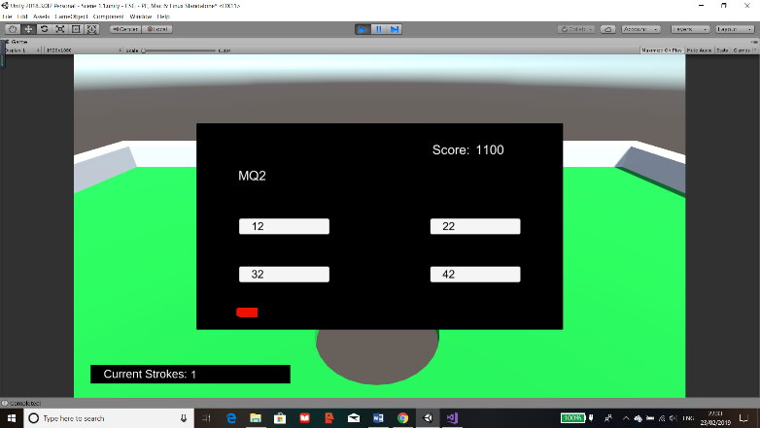

The images show that the time bar is a success as it begins from green and slowly changes to red until the bar reaches 0. When it does, a boolean is changed for the “Quiz” to run the same code as if the user answered incorrectly.

From the beta testing I carried out, there was suggestions of having visual feed back after answering a question. I will implement a method to display the correct answer to the user after they have answered the question.

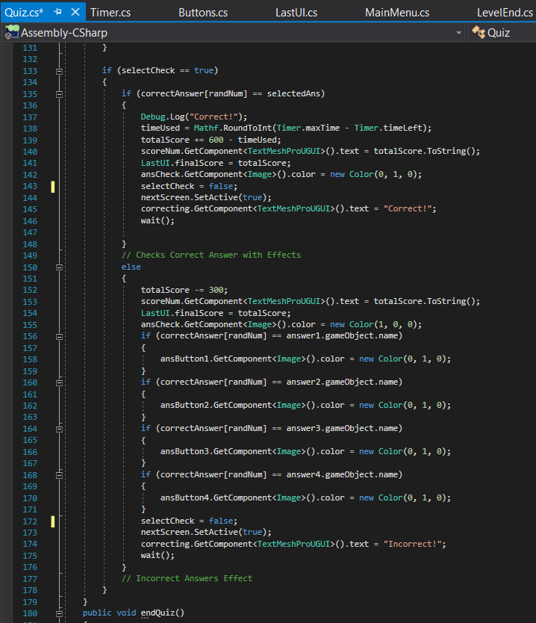

To have this work, I amended the code in the script “Quiz” by setting the correct answer button to green on after a button is clicked with the code “ansCheck.GetComponent<Image>().color”. The “ansCheck” holds the button which is the correct answer, this changes the colour to green only if the answer was correct. If it was incorrect, then in the else part, it sets the button chosen as red colour to indicate that the answer was incorrect. Then I have used 4 IF statements to check each button to the correct answer. Once there’s a match, which there should be, that button is set to green to indicate to the user that that was the correct answer.

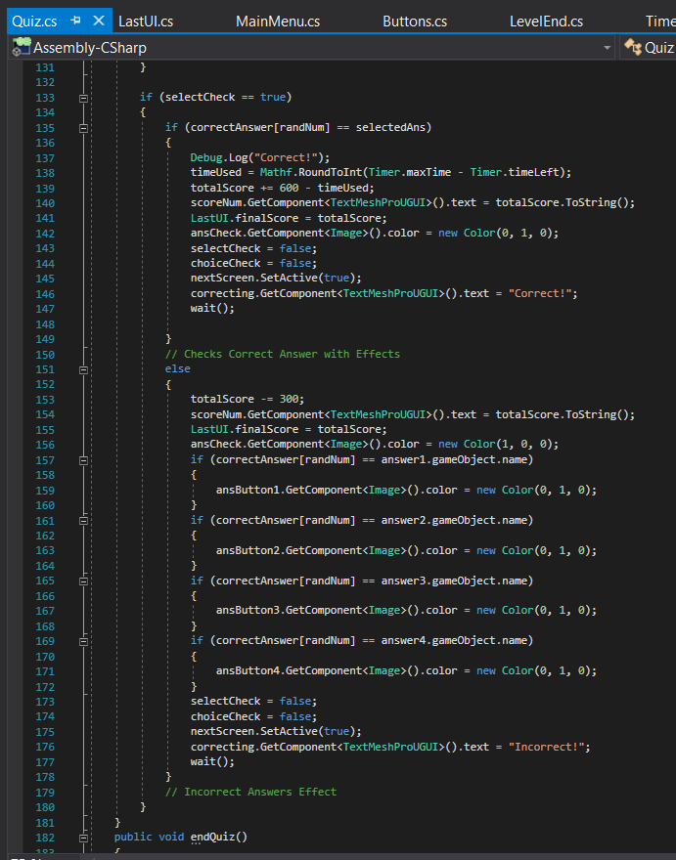Once the colours are displayed, I had to take into account my usability feature of colour blindness so I decided to create a final function to be called which will display text saying whether or not the chosen answer was correct. If incorrect, the user who is colour blind can see the highlighted choice that they didn’t pick as their correct answer.

This is achieved by adding another text object and just updating it depending if the answer was right or not. It’s updated by the code “correcting.GetComponent().text” where “correcting” is the variable which stores the text object. The image shown is for when the answer is correct and it’s the same code for the incorrect part except that the text is “Incorrect!”.

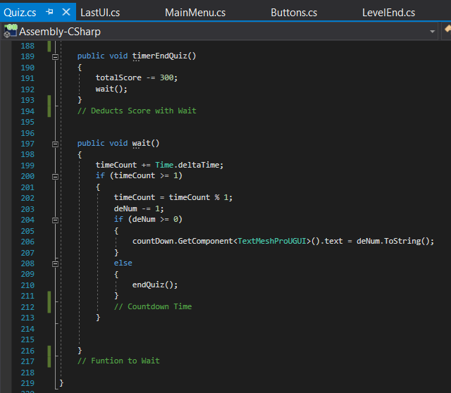Additionally I have introduced another function called “wait()”. This function is responsible for a countdown display for after the quiz is done so that the user will have time to check the correct answer and see where they went wrong. The countdown will also run even if their answer was correct, if not then the screen change may be too fast to be able to see that they were right in the first place.

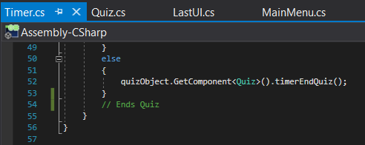

The function is called after the visual effects are ran for both right and wrong answers or if the timer has reached 0, then within the timer script, it will call the function “timerEndQuiz()” which deducts points then runs the countdown.

In the “wait()” function I have used “Time.deltaTime” to count up in seconds for the variable “timeCount” and for every second, the variable “deNum” is reduced by 1. This variable can be changed but I have set it to 10 seconds as it seemed a suitable time to wait. The text object “countDown” is constantly updated with the “deNum” to provide the effect that its counting down. The “deNum” had to be set to string by the use of “ToString()” as text objects only accept sting formats.

Once “deNum” is 0 or less, then the “endQuiz()” is ran and the quiz panel is removed from view for the next screen.

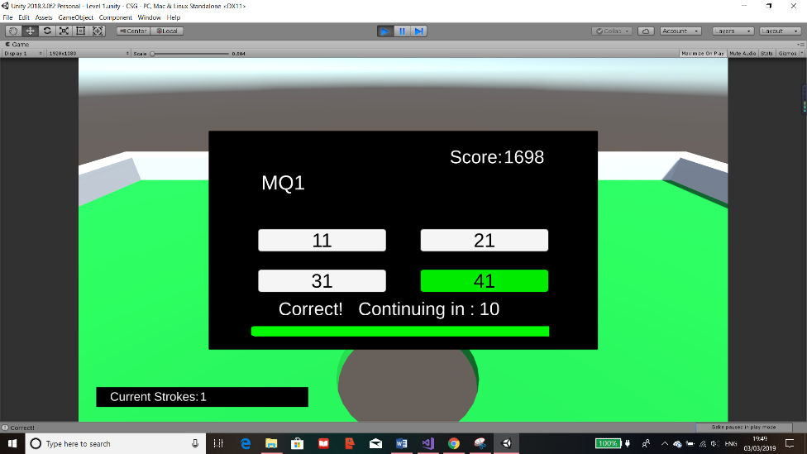

I have answered the question correctly to show that the colour assignment was right and the text successfully shows “Correct!”. The score has also updated.

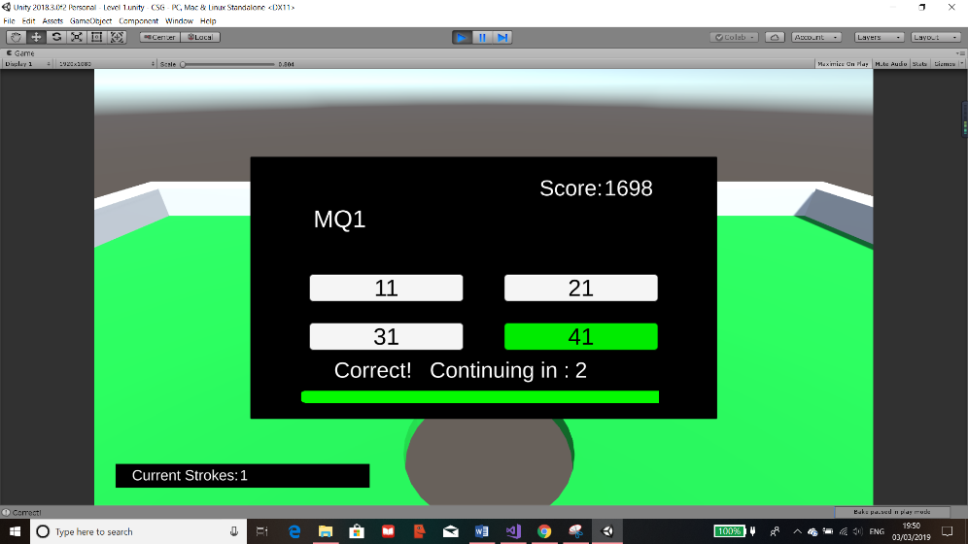

As this shows, the count down is successfully counting down and once it reaches 0, the panel successfully switches to the next.

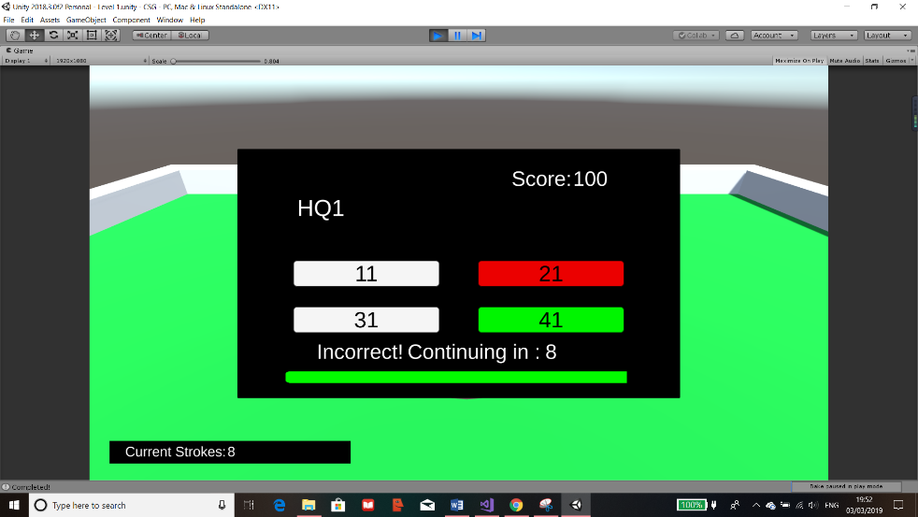

This is a test for if the answer was incorrect which was also successful. The text displays “Incorrect!” and the red is the option I clicked on and the green was the correct answer.

Error  
However, there was an issue where the user could spam the button and add or deduct even more to the score.

Solution  
To fix this, I simply made a boolean to make sure that after a button is pressed then the button press could not be running again until the scene is reloaded.

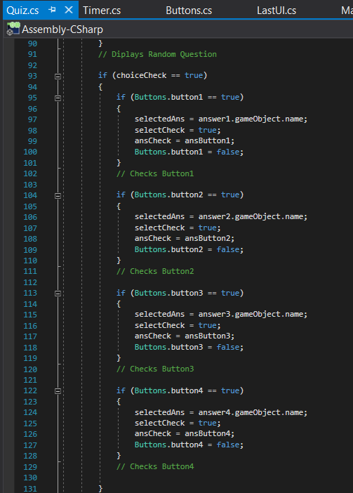

I made a new variable called “choiceCheck” as a boolean. This is initially set to true meaning the button check code can still be ran. This is only possible when the boolean is true. Therefore this means that once its set to false then the buttons would stop adding or subtracting score multiple times for the user.

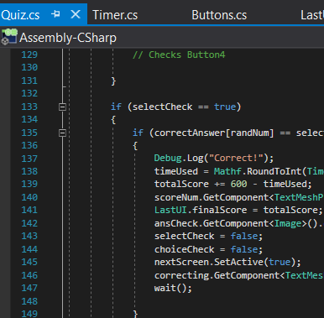

The “choiceCheck” is set to false just after the score is updated for the user and before the code can finish meaning that it can’t be repeated.

In conclusion this has resolved the problem and that the score cannot be tampered with whilst making sure nothing else would cause an error.

#### Final UI

The final thing required for each level would be a final display of the score and strokes of the user and the par for the level. There should be buttons for the next level or main menu.

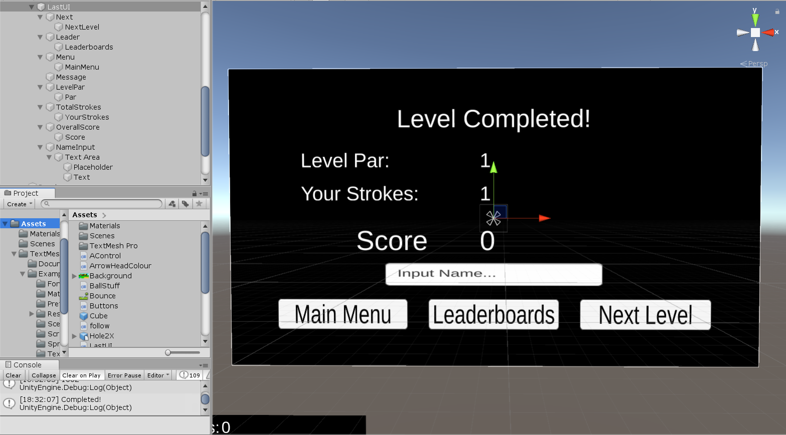

This is the panel design for the last UI, the button and text objects I used are shown on the left. There is also a “NameInput” for the leader boards.

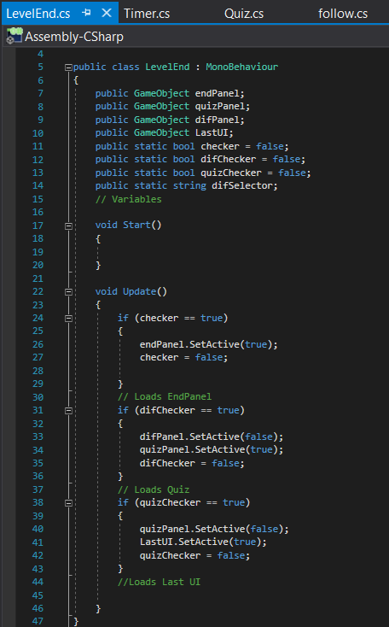

I have updated the scripts which are used to switch panels such as in “LevelEnd” and “Buttons”.

In “LevelEnd” I have included a new function which checks if the quiz has been completed and if it is then this new interface will load into view for the user.

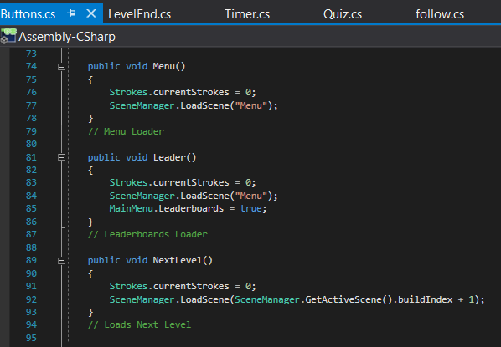In “Buttons”, I added 3 new functions which are to be attached to each of the buttons.

For “Menu()”, “currentStrokes” from “Strokes” is called and reset to 0, then I’ve used SceneManager to load the scene name “Menu”.

For “Leader()”, the strokes are still reset, then it loads the scene “Menu” but it sets a variable in “MainMenu” script to true, this will instantly update so that it will display the leader boards.

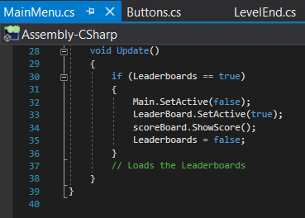

The final function is the “NextLevel()” which still resets the strokes but loads the next scene by getting the current scene using “GetActiveScene()” and its “buildIndex”. Then increasing it by 1, this can be done as the scenes I will use are in order starting from Main Menu, then level 1, 2, 3 etc.

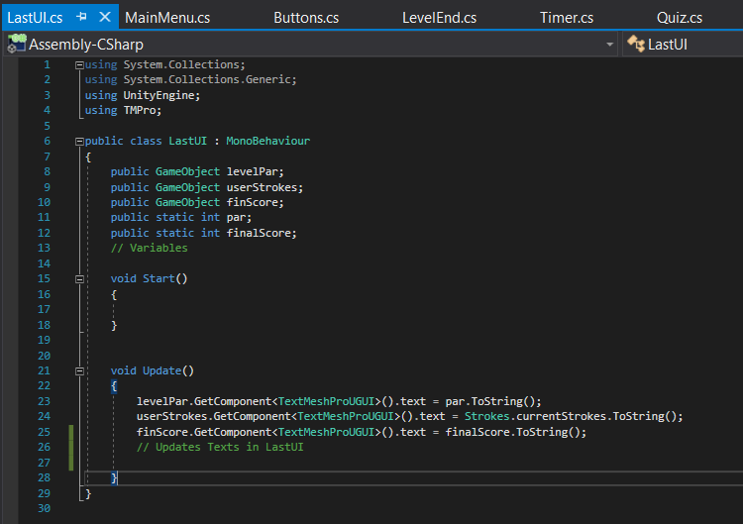

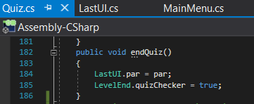

Finally, the last script is to update the 3 text objects to the final scores the user will see. The par is retrieved from the “Quiz” as it updates the variable when the quiz ends. This is done in the “endQuiz()” function.

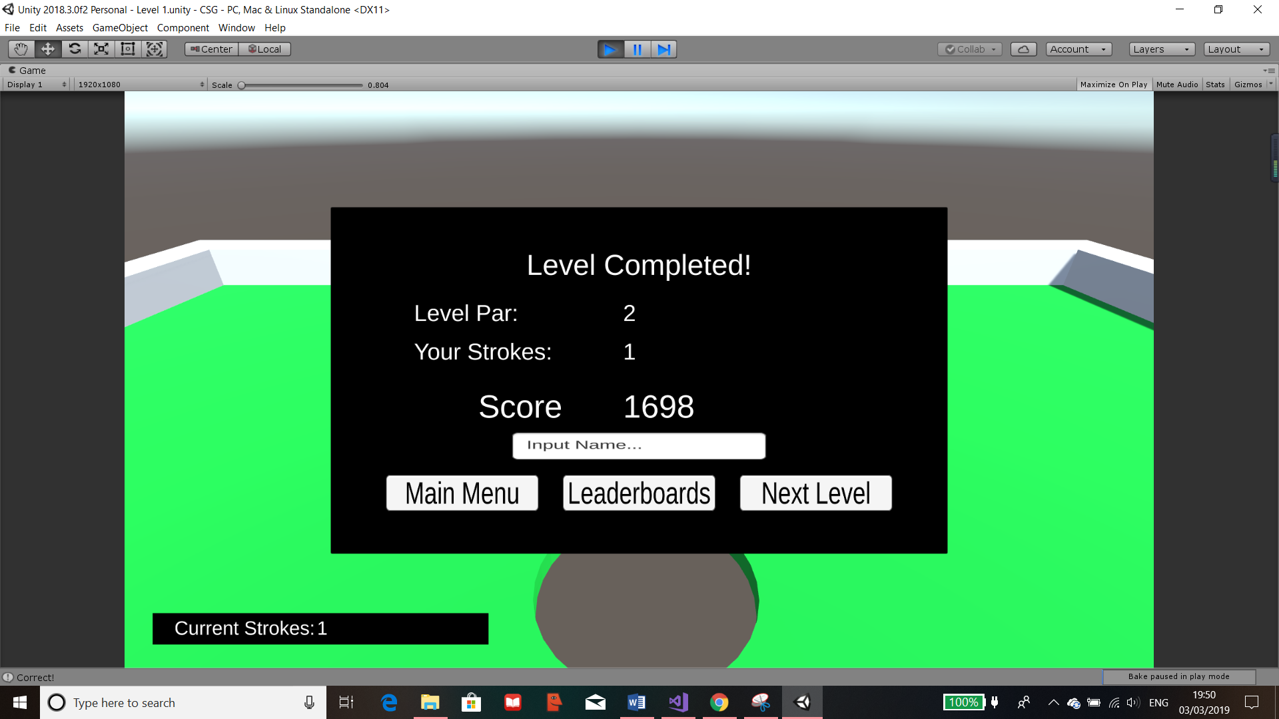

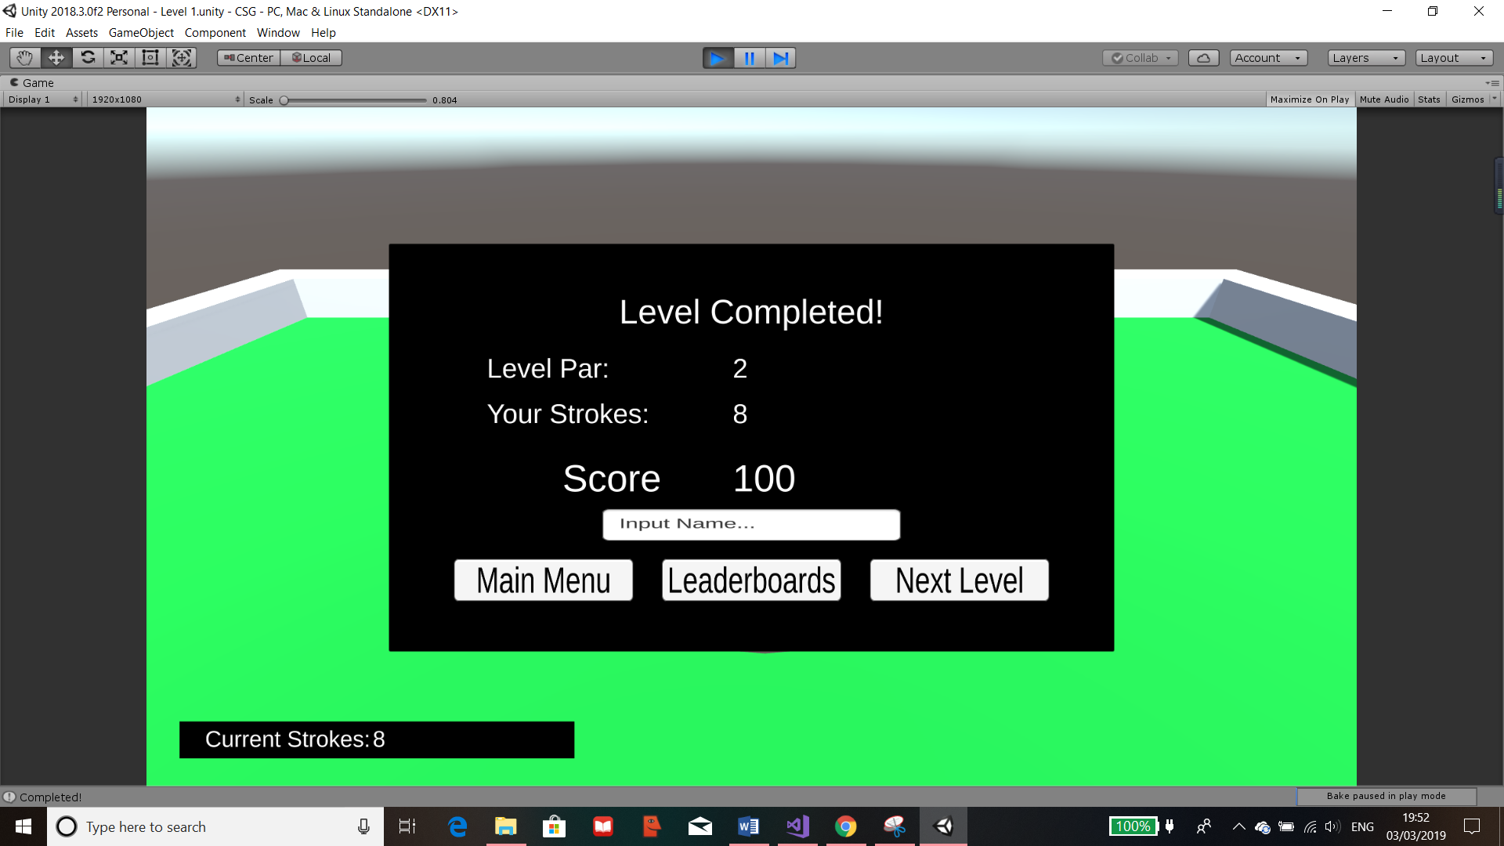

The results of the UI and buttons are shown here where I have tested when the stokes is less that the par (I.E Hole In One) and when its greater. The score has correctly updated accordingly and the buttons all work.

### Leader board

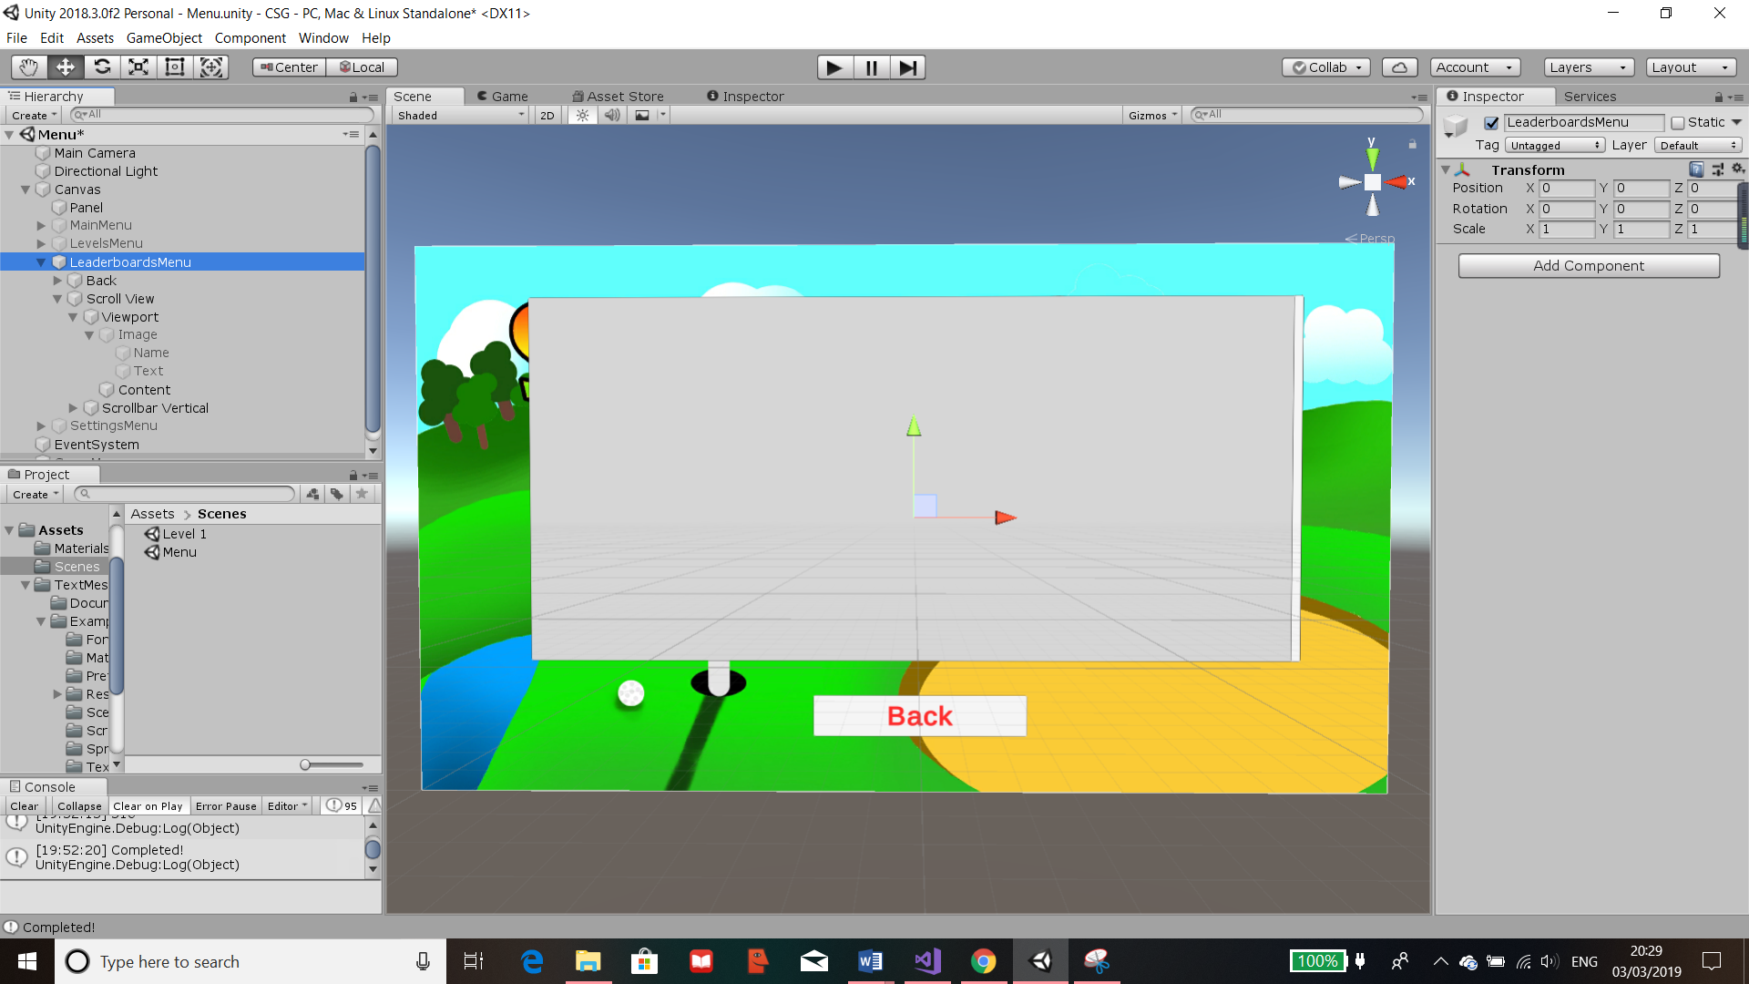As mentioned in my Success Criteria, I wanted to have a leader boards to show the users score and have them ranked which will provide a competitive part to the gaming. This means that they will be able to view and see their ranks in comparison to others and try to score better to achieve a higher rank.

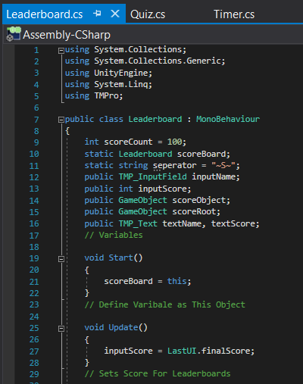I have updated the “LeaderboardsMenu” to have a “Scroll View” meaning that when data is added into this, it can be as large as it needs. This is due to the ability to scroll down the list and it will minimise any bugs that are involved with too much scores on the same panel. Therefore, this is how the leader boards will be shown.

This is the first part of the “Leaderboard” script. At the beginning of the class, all variables are set and defined.

Most of these define objects that are outside the script and will be attached.

The “scoreCount” is responsible for the amount of scores to display. I have set this to 100. The “separator” is the string which will be used to separate out a string as the name and score will be merged together as one entry. The “inputScore” is then the final score the user has, this is constantly retrieved and updated from the “LastUI” class in the “Update()” function. In “Start()”, “scoreboard” is defined to be “this” which means the object the script is attached to.

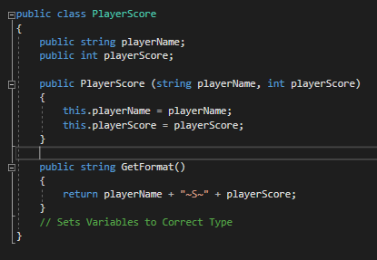Within the script, I have created another class called “PlayerScore”, I have created this here so that it will be easier for functions in the same script to call this.

In this class, it’s responsible to update the players name and score in the “Leaderboard” class whenever the function “PlayerScore()” is called. It’s also responsible for the formatting as shown in “GetFormat()” which provides each entry to be stored as a singular entry.

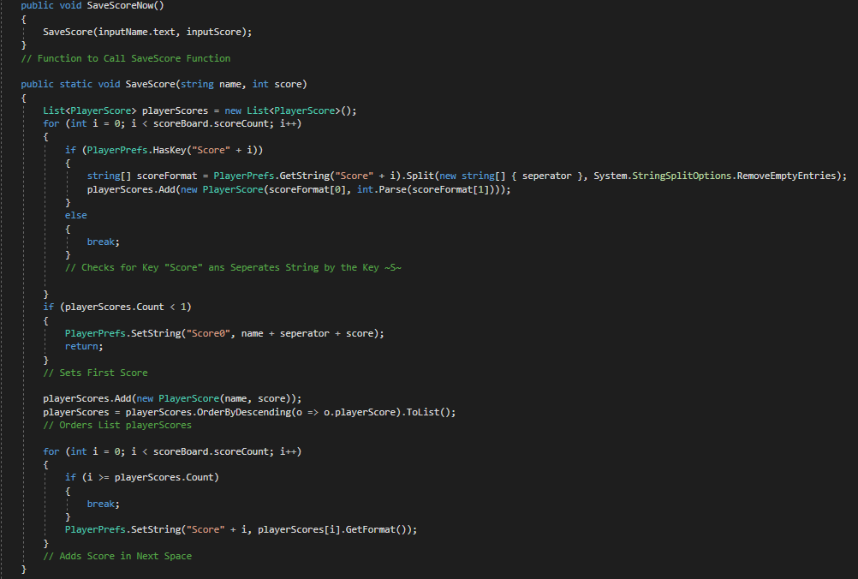

“PlayerPrefs” is a way Unity uses to store information set by me similar to text documents. However, they are stored by hashing so that the data is ordered by entry and it holds all the information on the data, also they are stored on the registry. This means that they could be stored on the school’s main server so that everyone would have access to the same leader boards and the same scores are updated and displayed.

To have the “SaveScore()” run, I have placed it in another function called “SaveScoreNow” so that the parameters passes will have the correct format beforehand.

The new list “playerScores” is created at the start of the function so that whenever a score is saved, a brand-new list is created and everything is re appended. This may seem illogical but it’s the best way to ensure that no duplicates could occur.



For the function “SaveScore()” the first “for” statement is used to count all the entries that are already in the “PlayerPrefs” and add them into the list “playerScores” in the format of an list where the first row of the array has the name then the second contains the score. It’s achieved by retrieving the current i in “PlayerPrefs” as an array with 2 parts as it was separated by the “separator” and the command “System.StringSplitOptions.RemoveEmptyEntries”. Then its saved as the string variable “scoreFormat” which is then appended into the list. Once all previous entries are recorded, it then runs “break” which just stops the for loop as its unnecessary to carry on.

When appending to the list, I have also used “int.Parse” which is a way unity coverts the data into an integer”



Then this “if” used to set the first score if the “PlayerPrefs” had no entries as “Score0”. The next line then saves the new score using the parameters that were passed down which were “name” and “score” into the list. It then orders the list so that it is descending for the users to see as ranks.



The final “for” statement is used to find the next free space in the “PlayerPrefs” by the use of the “if” checking for when i is larger or equal to the list “playerScores” which will have one additional entry to the pref as it was the new entry added previously. The same spot is then found as i would be the last entry in the list but the next empty in the “PlayerPrefs”. Once this is found, the name and score is added as a single entry as a string by using “.GetFormat()” which I have made and was shown before. This ensures that the “PlayerPrefs” has the same entries for future use because this can’t be deleted unless manually in the registries.

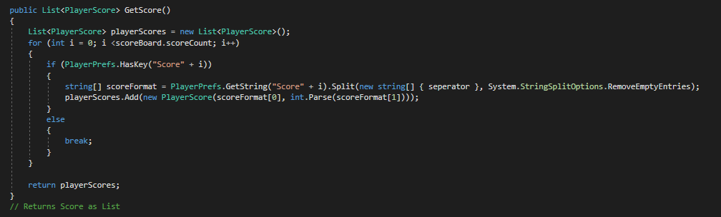

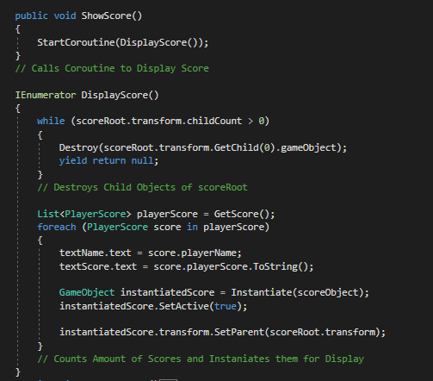The next function in the “Leaderboard” class is the “GetScore()” which is the same as “SaveScore()” because its used to create a new list with all the “PlayerPrefs” entry in the correct format however doesn’t add a new entry. Therefore, this is used to return the current version of the list “playerScores”.

Finally, the last functions are responsible for the actual displaying of the scores. “ShowScore()” is used to call “DisplayScore()” as IEnumerator can’t be directly called.

The “while” counts how many children objects are attached to the “scoreRoot” and deletes each all of them one at a time. This is done so no duplicates would be able to be generated.

The “playerScore” is retrieved by the function “GetScore()” which will create and return a list with all the up to date entries.

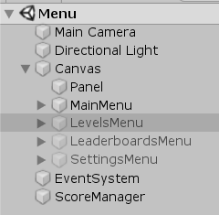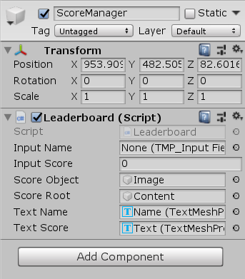The “foreach” command is ran the same number of times as the amount of “score” in the “playerScore” list. For each time this is ran, the “textName” and “textScore”, which is turned to a string using “ToString()”, from the list is retrieved and set to the text. Then an object is instantiated using a predefined prefab in the Unity menu. The instantiated object contains the “textName” and “textScore” and is set to active so that it is visible to the user. The object is then “transformed” (moved) as a child object of the parent object called “scoreRoot”. This is achieved by the function “SetParent()”.

The script is attached onto an object called “ScoreManager” which is outside a spectator object so that it can be always available. I then assigned all the variables as the correct ones and proceeded to test it.

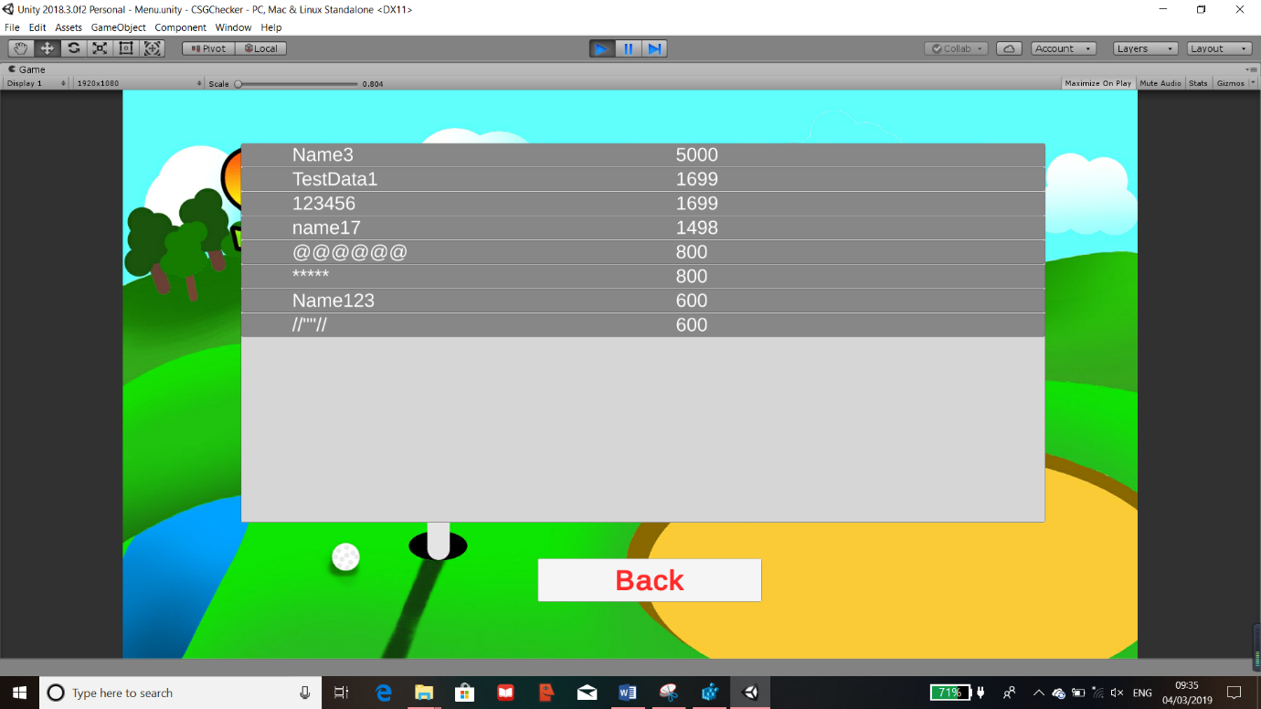

I have tried multiple different test data when trying out the level, the results of the leader boards are shown. As it shows, I have tried different symbols and text and they all work which I think is suitable. It is also correctly ordered where the highest score is at the top ad the rest as descending order.

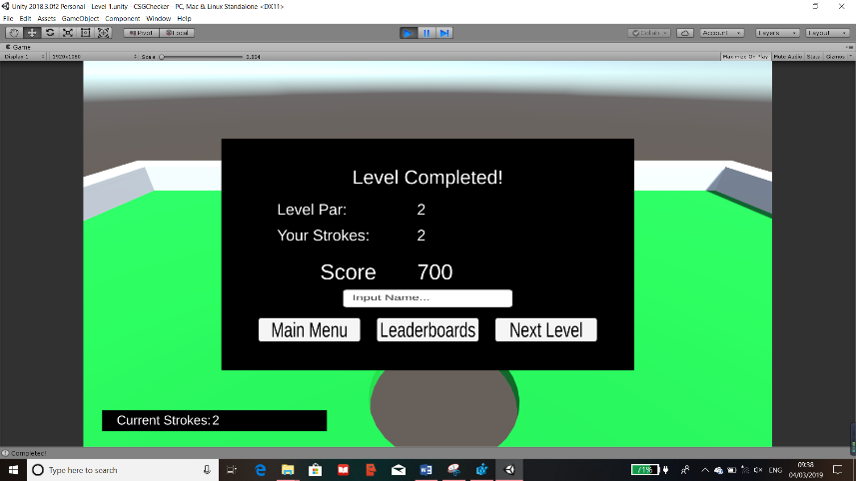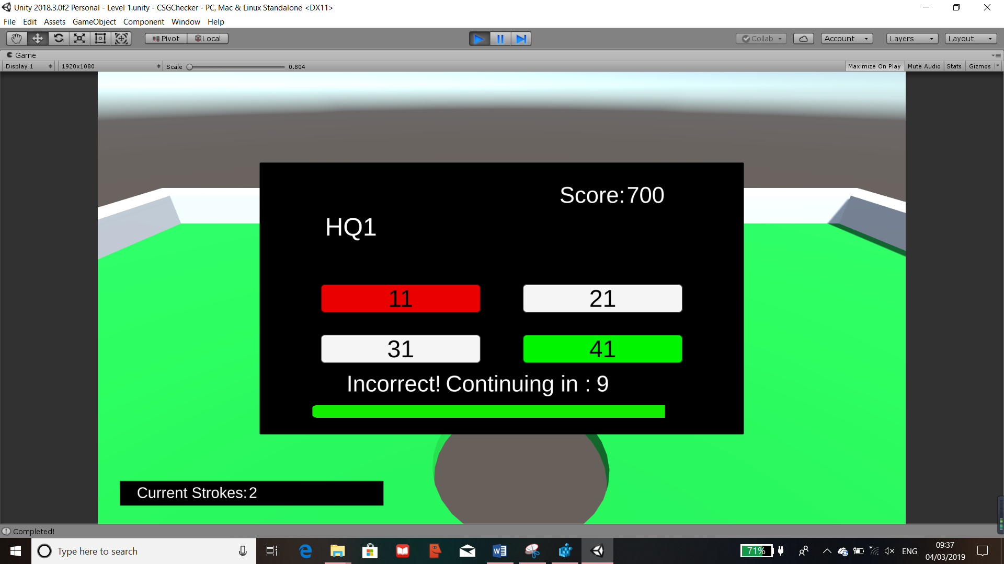

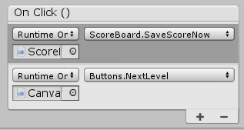After completing the quiz, everything is correctly displayed and my final test it to not put a name in. Which ever button is pressed, it’ll be saved into the “PlayerPrefs” for displaying. This is done by adding another function to be called in the “On Click()” component for each of the buttons which will therefore call “SaveScoreNow()”.

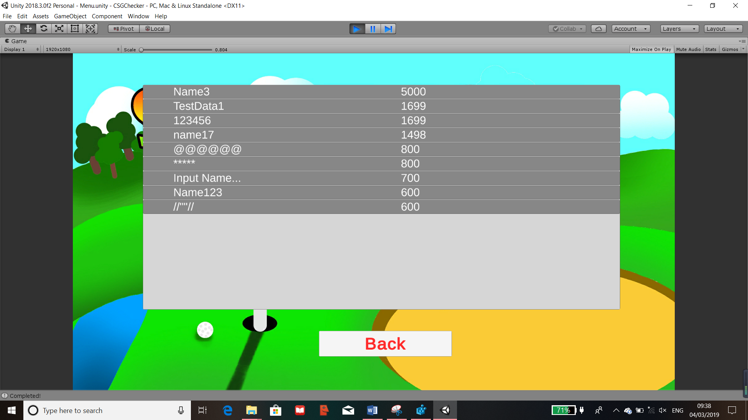

After clicking on “Leaderboards” button, it brought me directly to the leader boards with the updated score. This was a success as the leader boards has correctly updated and have been ordered. On the other hand, the name is displayed as “Input Name…” when a name wasn’t entered. Even though this is displayed, I left it as it still holds the score of the test trial. I’ve kept this so it means that when users play this, they don’t have to put a name down but still have their score within the leader boards.